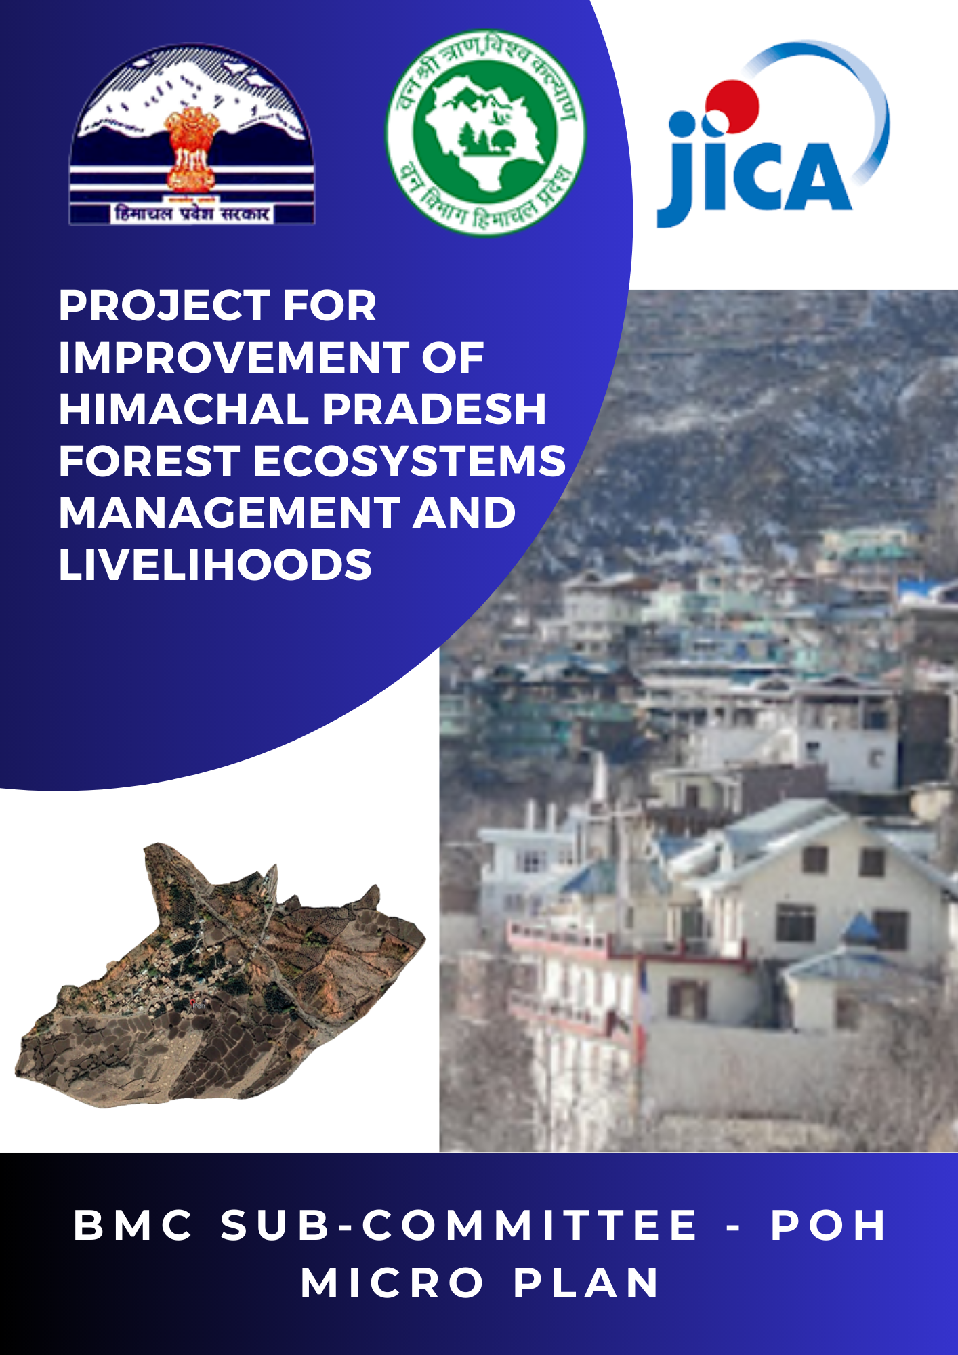
Contents
General Detail of Project Area: 7
LOCATION OF PROJECT AREA 8
Boundary Map of Poh 8
Location Map of Poh 9
Abbreviations and Acronyms 10
1. Introductionn 11
1.1 Project Brief 11
Project for Improvement of Himachal Pradesh Forest Ecosystems Management and Livelihoods 11
1.2Project Objectives 11
1.3 Project Target 12
1.4 Project Approach and Strategies 12
1.5 Mode of Operation 13
1.6 Need for Sub-Committee Level Micro Plan 14
2. Basic Information 15
2.1 Basic Information Sheet on Micro plan 15
2.2 General Profile of Selected BMC Sub-committee 16
2.3 Details of the EC Members of the BMC Sub-Committee Tabo 17
2.4 Micro Planning Process 18
3. Socio-Economic Profile of Poh 20
3.1 General Description of the BMC Sub Committee 20
3.1.1 History of Area Selected 20
3.1.2 Location of BMC Sub-Committee Area 20
3.1.3 Boundaries 20
3.1.4 Distance from 20
3.1.5 Important features of BMC Sub-Committee 20
3.2 Social Composition 21
3.3 Population 23
3.4 Educational Status 23
3.4.1 Educational Status 23
3.5 Economic Categories 24
3.5.1 Wealth ranking as per PRA exercise 24
3.5.2 Above and Below Poverty Line (As per the Government Criteria) 24
3.6 Access to Basic Facilities/Services 24
4. Resource Analysis 25
4.1Land Resources 25
4.1.1 Land Use Pattern 25
4.1.2 Land Ownership Pattern 25
4.2 Forest Resources 26
4.2.1 Forest Area 26
4.2.1.1 Site selection and location 26
4.2.1.2 Data from Wildlife Forest Division for Community Based Biodiversity Management Plan 26
4.2.1.3 Description of the forest 26
4.2.1.4 Selection of Intervention areas, planning and treatment: 28
4.2.1.5 Data and Maps on Grazing, fire and other risks 28
4.2.1.6 Human Wildlife Conflict 29
4.2.1.7 Data and Maps on intervention areas/treatment plots 29
4.3 Trend in Community Dependency on Forests (as per PRA exercises) 30
4.4 Households dependent on Forest (As per PRA exercises) 31
4.5 Forest Resources of the selected area (As per the PRA exercise) 31
4.6 Biodiversity (BMC Use) 32
4.7 NTFP Collection (as per PRA exercises) 34
4.8 Fuels Collection/Consumption 35
4.9 Fuels/Fuel wood Deficiency 35
4.10 Fodder collection/consumption 36
4.11 Fodder Deficiency 36
4.12 Timber 37
4.12.1 Timber Deficiency 37
4.13 Forest Management Practices 38
4.14 Forest Protection Practices 39
4.15 Water Resources 40
4.16 Agricultural resources 41
4.16.1 Cultivable land use pattern 41
4.16.2 Land holding pattern 41
4.16.3 Cropping Pattern 42
4.16.4 Challenges of Cultivable Land 43
4.16.5 Livestock Resource 44
4.16.5.1 Livestock Holding Pattern 44
4.16.5.2 Production of main Livestock 44
5. Livelihood Strategies 45
5.1 Existing Livelihood Strategies 45
5.2 Livelihoods- Activity Calendar 46
5.3 Food deficiency 47
5.4 Income deficiency 47
6. Institutional Analysis 48
6.1 Existing Community Based Organisations (CBOs) 48
6.2 Preferences for External Linkages 49
6.3 Profile of existing SHGs 49
7. Problem Analysis and Solution 50
7.1 Analysed Problems and Scientific Solutions 50
7.2 Perceived Problems and Solutions 51
7.3 Implementation Activities/Interventions 52
7.4 SWOT Analysis 54
7.5 Setting the objectives for Development for the project duration 55
8. Forest Ecosystem Management Plan 56
8.1 General description 56
8.1.1 Memorandum of Understanding 57
8.1.2 Project Support to the beneficiary BMC Subcommittee for implementation of Micro plan 57
8.2 Activities for plantation 58
8.3 Requirements of Planting Materials 58
8.4 ForestProtection/Silviculture/MaintenanceoperationforthePlantation 59
8.5 Plantation Activity under PFM Mode 59
8.6 Soil and water conservation 60
8.6.1 Soil and Water Conservation Works (Proposed) 60
8.6.2 Soil and Water Conservation works (Year wise Physical Target) 60
8.7 Physical and Financial Plan (FEMP) 61
8.7.1 Proposed physical and financial plan 61
8.7.2 Annual Work Plan for 2023-2024 62
9. A BRIEF APPROACH OF SATOYAMA UNDER THIS PROJECT 63
Problem Analysis and Solution 67
Analysed Problems and Scientific Solutions 67
Perceived Problems and Solutions 68
SatoYama Activities 69
9.1 Satoyama Activities 69
9.1.1Physical & Financial details of SatoYama activities 70
9.2Livelihood Improvement/Income Generation Activities (IGAs) 71
9.3Proposed Physical and financial coverage of livelihood improvement and Income Generation Activities 72
9.5Annual Work Plan for Community Development and Livelihood Improvement (CD&LIP) 73
10. Activities identified in Poh BMC 74
10.1 Activities identified and implementing agecies 74
10.2 Proposed Physical & Financial Coverage of Activities identified 75
11. Implementation Strategies 75
11.1 Implementation guidelines on components and sub-components 76
11.2 Training and capacity building of community institutions (BMC Subcommittee, SHG) 76
11.3 Year wise detail of training and capacity building plan 77
11.4 Proposed year wise trainings/ capacity building of community institutions 77
11.5 Records to be maintained by the Community Institution 77
ANNEXURES 79
Annexure-I 80
Social map of Poh BMC Subcommittee 80
Annexure-II 81
Resource map of Poh BMC Sub Committee 81
Annexure-III 82
Aerial image map: Survey & Mapping of Intervention area 82
Annexure-IV 83
Contour Map: Survey & Mapping of Intervention Area 83
Annexure-V 84
Land Use Cover Map: Survey & Mapping of Intervention Area 84
Annexure VI 84
Forest Cover Map: Survey & Mapping of Intervention Area 85
Annexure VII 86
Copy of the proceedings of the general body: 86
Annexure VIII 89
Panchayat resolution copy: 89
Annexure IX 90
Joint Declaration from Promoter Members 90
Annexure X 91
MoU between DMU and President BMC Subcommittee copy: 91
Annexure XI 96
Certificate of Registration of the BMC Subcommittee 96
Annexure XII 97
Copy of Bylaws 97
Annexure XIII 111
Photos during Micro Planning Process 111
Annexure XIV 112
Micro Plan Assessment Criteria for Financing and Sanctioning 112
Annexure XV 114
Total Budget of BMC Sub Committee at Glance 114

General Detail of Project Area:
Gram Panchayat | Tabo
BMC | Tabo
BMC Sub-Committee | Poh
Forest Block | Tabo
Forest Beat | Poh
Forest Range | Wildlife Range, Tabo
Forest Division | Wildlife Division, Spiti
Forest Circle | WildLife South, Shimla
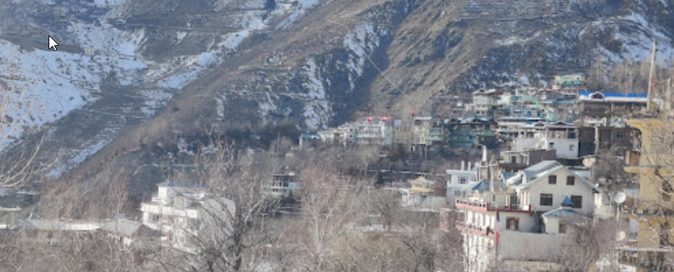

LOCATION OF PROJECT AREA

Boundary Map of Poh
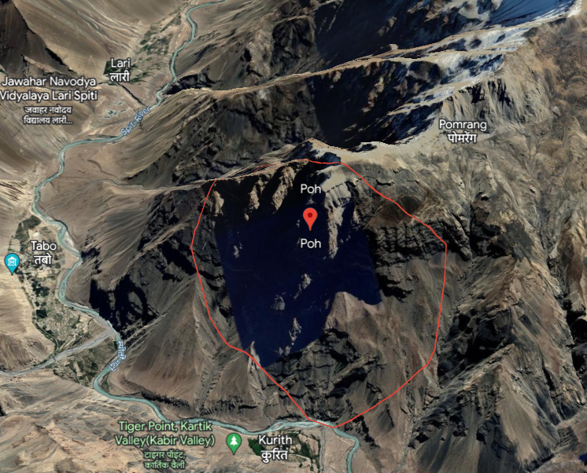
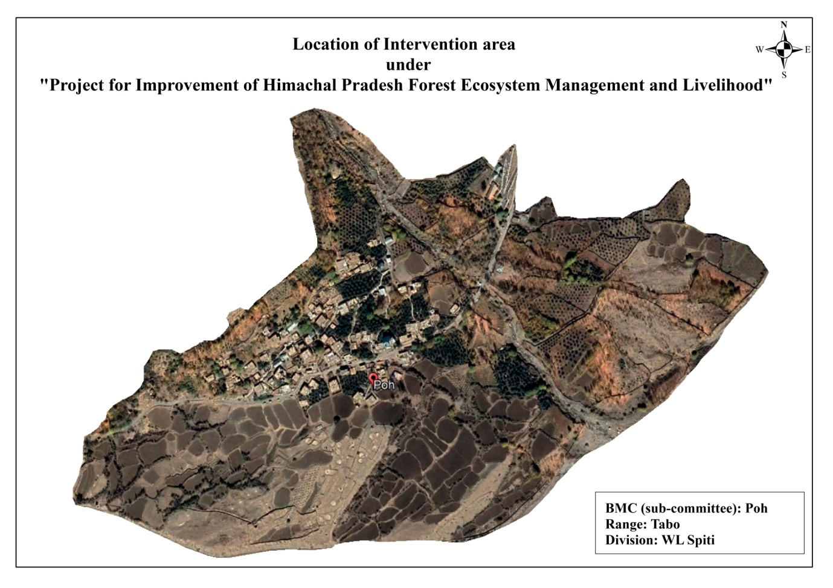

Location Map of Poh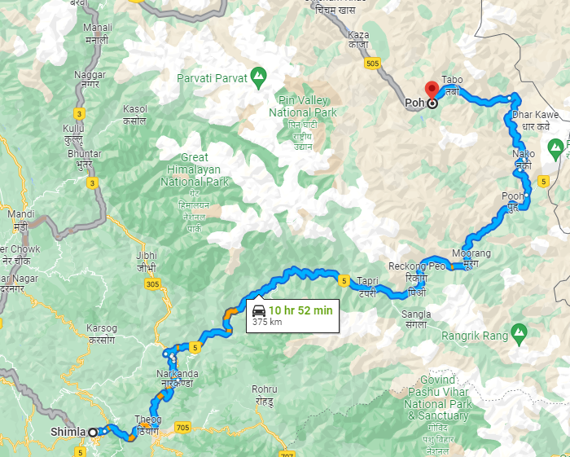

Abbreviations and Acronyms
ADMU | Assistant Divisional Management Unit
ANR | Assisted Natural Regeneration
BMC | Biodiversity Management Committee
BO | Block Officer
FEMP | Forest Ecosystem Management Plan
EC | Executive Committee
CD&LIP | Community Development & Livelihood Improvement Plan
CIG | Common Interest Group
DMU | Divisional Management Unit
SMS | Subject Matter Specialist
FCCU | Forest Circle Coordination unit
Fgd | Forest Guard
FTU | Field Technical Unit
GIS | Geographic Information System
FD | Forest Department
GOHP | Government of Himachal Pradesh
GP | Gram Panchayat
Ha | . Hectare
HHs | Households
HP | Himachal Pradesh
HPFD | Himachal Pradesh Forest Department
IFMS | Integrated Forest Management System
IGA | Income Generation Activities
INR | Indian Rupees
JICA | Japan International Cooperation Agency

MIS | Management Information System
MM | Mahila Mandal
NR | Natural Regeneration
NTFP | Non-Timber Forest Produce
O&M | Operation and Maintenance
PFM | Participatory Forest Management
PIHPFEM&L | Project for Improvement of Himachal Pradesh Forest Ecosystems Management & livelihoods
PMC | Project Management Consultant
PMU | Project Management Unit
PRA | Participatory Rural Appraisal
RRA | Rapid Rural Appraisal
RFO | Range Forest Officer
SHG | Self Help Group
SWC | Soil Water Conservation
TOT | Training of Trainers
VFDS | Village Forest Development Society
YM | Yuvak Mandal
WHS | Water Harvesting Structure

1. Introductionn

1.1 Project Brief

Project for Improvement of Himachal Pradesh Forest Ecosystems Management and Livelihoods

1.2Project Objectives
The objective of the project is to manage and enhance the forest area ecosystem in the project area, by sustainable forest ecosystem management, biodiversity conservation, livelihoods improvement support, and strengthening institutional capacity, thereby contributing to environment conservation and sustainable, socioeconomic development in the project area in the state of Himachal Pradesh.

1.3 Project Target
The JICA mission and HPFD agreed that project activities under a non-departmental mode shall be undertaken by the Village Forest Development Society (VFDS) which also includes Joint Forest Management Committee (JFMC) based on Participatory Forest Management Regulation and Biodiversity Management Committee (BMC) sub-committee based on Biological Diversity Act, 2002 at Ward level. Both sides also confirmed that any fund for the project activities shall be transferred directly from Divisional Management Unit (DMU) to VFDS/BMC sub-committee.

1.4 Project Approach and Strategies
The project aims to sustainably manage and enhance the ecosystems of the forests in the project area by project interventions under four components in correspondence with the project outputs as below. Each component has the preparatory phase, implementation, and phase-out phases.
Output 1: Sustainable Forest Ecosystem Management
Output 2: Biodiversity Conservation
Output 3: Livelihoods Improvement Support
Output 4: Institutional Capacity Strengthening
1.5The basic approaches to be followed under the project to achieve the project objectives include;
- Empowering forest-fringe communities, particularly women, through sustainable livelihoods and ensuring positive involvement of rural people in managing their own environment.
- Strengthening community institutions such as the Village Forest Development Society (VFDS) and Biodiversity Management Committees (BMCs)/subcommittees.
- Alleviating poverty
- Appropriate Silvicultural operations utilization of the inherent potential of available rootstock, underplanting with suitable species, and block plantations in blank patches.
- Promoting inter-sectoral convergence (ISC).
- Interventions to be planned and implemented by VFDS/JFMCs and Biodiversity Management Committee/subcommittees (Micro planning).
- Capacity Development of Himachal Pradesh Forest Department and VFDS/JFMCs.
- Promoting forest-based and non-forest-based enterprises (such as the value addition and marketing of medicinal & aromatic plants, etc.) to generate sustainable employment, develop industries, and enhance the value of forests.
- Caring for the socially disadvantaged groups in the society, such as scheduled castes, Scheduled Tribes, forest dwellers, women, and other vulnerable people through proper safeguard measures as per the JICA guidelines and applicable Indian laws and regulations.
- Institution capacity strengthening of the Forest department and its personnel.

1.5 Mode of Operation
The identified areas shall be divided into Participatory Forest Management (PFM) Mode and Departmental Mode. In case identified potential interventions areas are away from communities but interventions are required for the purpose of the Project and the PFM institutes (VFDS/BMC sub-committee) show their unwillingness to work in these areas, such interventions are to be conducted in the departmental mode. However, the PFM mode shall be selected where applicable from the viewpoint of sustainability. The major activities to be implemented under different modes include as below:
PFM (Participatory Forest Management) Mode
- Drainage Line Treatment including ex-situ Soil & Water Conservation (SWC) work
- Densification of moderately dense forests by Plantation of multi-purpose trees in degraded forests so as to convert open forests into moderately dense forests and moderately dense forests to dense forests; gap plantations should be preferred to be more effective in larger areas.
- Afforestation/ Improvement of Open/ Scrub Forest
- Rehabilitation of Forest Areas Infested with Invasive Species
- Improvement of Pastures/ Grasslands (including in-situ SWC works)
- Forest Fire Protection
- Forestry Intervention Outside of Forest Areas
Departmental Mode
- Improvement of Forest Boundary Management in Project Intervention Areas
- Improvement of Nurseries
- Seedling Production
- Non-PFM Drainage Line Treatment (ex-situ SWC work: including treatable
- Surface Erosion Control
- Secondary Silvicultural Operations for the Improvement of Existing Forests
- Improvement/ Densification of Moderately Dense Forest
- Improvement of Pastures/ Grasslands (including in-situ SWC work)
- Forest fire management Afforestation/ Improvement of Open/ Scrub Forest

In addition, the Community Development & Livelihood Improvement Plan (CD & LIP) will be executed by PFM institutions including Common Interest Groups (CIG), User Groups, Self-help Groups (SHGs), and Executive Committee of the BMC Subcommittees.

1.6 Need for Sub-Committee Level Micro Plan
All the Project activities at the BMC sub-committee level shall be undertaken after a long-term (5-7 Years) development/ perspective micro plan is prepared.
• Micro Planning shall be considered as an empowering process that helps the BMC sub-committee to learn more about themselves, their resources, issues and challenges, strengths and weaknesses, and further plan for their own development and sustainable resource management.
• The implementation of PIHPFEM&L activities at the BMC sub-committee level shall be guided by an approved Micro Plan prepared by the respective BMC sub-committee. Micro plan preparation shall be the first step of implementation of the field activities.
• Micro Plan shall be a comprehensive development plan with a special focus on forest and livelihood development. The micro plan shall cover both forest and non-forest areas managed by the BMC sub-committee. The micro plan shall integrate the needs of the BMC sub-committee into the comprehensive plan through analysis of current conditions, social assessment, and interaction with the members, and with reference to the prescriptions of the Working Plan of the Forest Division.
• Micro Plan will not only focus on forestry activities and it should be comprehensive so as to include all development activities that may be taken up by other Government Departments and Agencies through convergence. During the preparation of the micro plan, the BMC sub-committee shall interact with officials of other departments and after the preparation of the Micro Plan, it should be shared with other Government Departments and Agencies for dovetailing their activities in the BMC sub-committee.
• A Micro Plan shall consist of two types of sub plans;
i) Forest Ecosystem Management Plan (FEMP) and,
ii) Community Development and Livelihood Improvement Plan (CD&LIP) and shall be aggregated by FTU for each range.
• Under the Micro Plan composed by FEMP and CD&LIP, the broad action plan is to be prepared for 5 years based on the 10 years vision. During the exercise, the achievements of the previous year shall be assessed, and identify issues and corrective measures to further increase the efficiencies and effectiveness of the project implementation.
• In the annual planning undertaken during the 4th year, a broad action plan shall be prepared for the forthcoming 5 years. The 2nd 5-year action plan process shall follow the same step as discussed in the above section.
• A copy of the Micro Plan, when prepared, shall be shared with the Gram Panchayat, Block Development Office (BDO), and other Line Departments for dovetailing their activities in the BMC sub-committee.
• Although Micro Plan shall be prepared for 6-8 years, it would be revisited annually.

2. Basic Information

2.1 Basic Information Sheet on Micro plan
1. | Name of the BMC sub-committee | Poh
2. | Name of the Ward | Poh
3. | Registration No. of BMC subcommittee | HPCD-6159
4. | Name of Gram Panchayat | Tabo
5. | Name of the FTU/ Range | Tabo
6. | Name of the DMU/Forest Division | Wildlife Division, Kaza, Spiti
7. | Name of the District | Lahul & Spiti
8. | Period of Micro Plan | 24/06/2023 to 31/07/2023
9. | Date of approval of Micro Plan by Executive Committee of BMC  sub-committee | From: To:  (BMC resolution for approval of micro plan attached)
10. | Date of approval of Micro Plan by  DFO/ Head of DMU | 6/12/23
11. | Key team members engaged in  Preparation of Micro Plan | FTU Chhodon  FTU Minakshi  SMS Ashutosh Pathak
12. | Date of General House conducted & resolution passed | 18/04/2021
13. | Number of Participants | 26
14. | Number of members in EC | Male: 5 Female: 4 Total: 09

2.2 General Profile of Selected BMC Sub-committee

S. No | Description | Current Status
3. | Date & Registration of BMC Sub-committee | 03/06/2022
4. | No. of Revenue Ward/ Forest  Villages covered | 1(Poh)
5. | Total number of households (HHs) in Ward | 80
6. | Total No of households representing BMC subcommittee | 80
7. | Total Population | 386
8. | Total General Categories HHs | Nil
9. | Total SC HHs | 15
10. | Total ST HHs | 65
11. | Total IRDP/BPL HHs | 15
12 | Total Livestock Population | 253
13. | Bank account details | Saving Account
 | Name of the bank | SBI
 | Date of account opened
 | Account number /IFSC | FEMP-50076137491  CD&LI-50076137504

2.3 Details of the EC Members of the BMC Sub-Committee Tabo
 | Name | M/F | Age | Designation | Occupation | Contact No.
1. | URGAIN TANDUP | M | 28 | President/Chairman/Director | Farmer | N/A
2. | TANZIN CHHAKDOR | M | 27 | Vice President/Vice Chairman | Student | N/A
3. | ANJALI | F | 24 | Secretary/General Secretary | Student | 9418411496
4. | RAMESH | M | 55 | Treasurer/ Finance Secretary | Block Officer | N/A
5. | TSERING DOLMA | F | 23 | Executive Member/ Member | Student | N/A
6. | MEENA KUMARI | F | 36 | Executive Member/ Member | House Wife | N/A
7. | SONAM JANGCHUB | M | 27 | Executive Member/ Member | Student | N/A
8. | SONAM YOGDON | F | 23 | Executive Member/ Member | Student | N/A
9. | DEVENDER SHARMA | M | 27 | Executive Member/ Member | FGD | N/A

2.4 Micro Planning Process
The BMC Subcommittee-level micro-planning process consists of Forest Ecosystem Management Plan (FEMP) and Community Development & Livelihood Improvement Plan (CD&LIP). For activities to be implemented through line departments/agencies, details of the Convergence activities are also added to the Micro Plan. The detailed process followed in the preparation of the micro plan focuses on the information collection from primary sources, secondary sources, ward-level meetings, and other meetings held with primary and secondary stakeholders. The information was also collected from different sections of the community using Participatory Rural Appraisal (PRA) and Rapid Rural Appraisal (RRA) techniques.
The information collected mostly focused on PRA techniques focused on group discussions with the specific groups which include vulnerable families; ST; SC and Women. The information collected was triangulated with different groups and at last finalized in a plenary session.
The information collected was analyzed jointly with the active members of the BMC subcommittee and other community participants. A meeting was conducted to share the primary information collected. The changes were incorporated based on the participant’s consensus.
The participants were asked to gather in a group to discuss and identify their problems, perceived needs, and priorities by giving certain exercises of PRA tools and finally suggested the possible solutions to deal with their needs & priorities which emerged during the group exercises where women and men were given maximum opportunities to bring forward forest-related and livelihood related issues. A detailed set of perceived problems and solutions were developed jointly by Sub-Committee members and the micro-planning team of the project.
The perceived problems, solutions, and information collected through primary and secondary sources were discussed with the General House of Sub-Committee. A refined set of problems and solutions emerged to take it forward for inputs from the technical staff and the experts to finalize the Micro Plan, especially the FEMP. The Executive Committee was also formed in the General House according to the HP Forestry Project guidelines. For Forestry interventions, User Groups were also formed.
The technical staff of HPFD and the Community focused on quantification and decided on a tentative target for different interventions and prepared cost estimates based on the Project norms and locally prevailing rates. The micro plan is finalized by consultation with Divisional Management Unit (DMU) staff, Field Technical Unit (FTU) staff, and Executive Committee of Sub-Committee and inputs from the other experts.
The details presented in the following table indicate the critical steps followed in micro-planning process.
S.N. | Sequential Steps Followed – Addition can be made as per the locally followed process | Date | Frequency
1. | Community awareness building meetings/workshops organized at GP & ward Level | 18/04/2021 | -
2. | GP Consent to work with project | 20/04/2021 | -
3. | Sub-Committee formed/Executive committee constituted /Sub-Committee Registered. | 03/06/2022 | -
4. | Action plan prepared with Sub-Committee for Micro Plan Preparation | 15/02/2023 | -
5. | Micro planning process started /PRA exercise conducted (From- To) | 22/06/2023 to 31/07/2023 | -
6. | Participatory information analysis carried out (From- To) | 15/07/2023 to 29/07/2023 | -
7. | Negotiation/planning process held (From- To) | 02/08/2023 to 30/08/2023 | -
8. | Participants involved in negotiation/planning process (Male & Female) | - | 19 M  9 F
9. | Presentation of the draft plan in village/ward assembly for approval | 28/08/2023 | -
10. | Documenting the micro plan (From- To) | 05/09/2023 to 10/10/2023 | -
11. | MOU signed between DMU and EC of Sub-Committee for undertaking micro planning and implementation | 24/07/2023 | -

3. Socio-Economic Profile of Poh

3.1 General Description of the BMC Sub Committee

3.1.1 History of Area Selected
The Poh village is situated in the Lahul and Spiti district with district. Spiti is the sub district (tehsil / mandal), is a low-level administrative division of a district, of this village. Spiti is the Community Development Block (C.D. Block) of this village with C.D. Block code number 0024. Kaza is the Sub-district headquarters of this village and it is situated 37 kilometers away from this village. The district headquarters' name is Kyelong and as per distance concern it is 224 kilometers from the Poh (173/1) village.

3.1.2 Location of BMC Sub-Committee Area
BMC Sub-Committee falls under;
Village |  | Poh
Panchayat |  | Tabo
Block |  | Tabo
District |  | Lahul &Spiti
Beat |  | Poh
Range |  | WL Range Tabo
Forest Division |  | WL Spiti
Location map of Sub-Committee is attached on Page No.

3.1.3 Boundaries
The boundary of selected BMC Sub-Committee area is under
East | Tabo
West | Way to Kaza
North | Mountain
South | Spiti River

3.1.4 Distance from
WL Range Office: | 10 KMs
WL Division Office: | 40 KMs
State Capital Shimla: | 400 KMs approximately.

3.1.5 Important features of BMC Sub-Committee
Poh is famous for the cultivation of Apples and Peaches. The area is near to Tabo which has a thousand years old Monastery which holds the significance importance to the local community. The main highway towards Kaza and Chandartal passes through the Poh Village and sees significant number of tourists through the year apart from harsh winter.

3.2 Social Composition
Households (HHs) | ST | SC | OBC | General | Total
No of HHs | 65 | 15 | - | - | 80
% of HHs | 81.25% | 18.75% |  |  | 100%

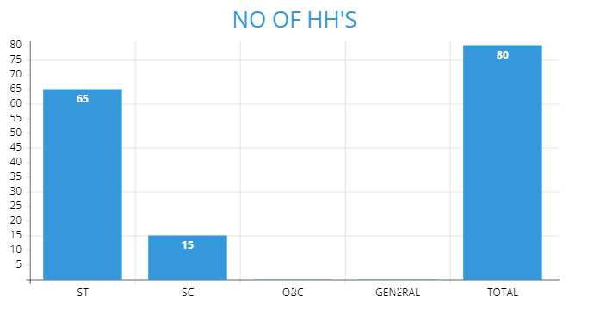
In Poh BMC Sub-Committee 65 households belongs to ST category (81.25%) and 15 Household (18.75%) belongs to SC category out of 80 households in total.

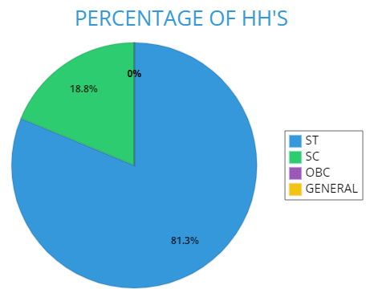

3.3 Population
Social category |  |  | Population (Number)
 | Male Adults | Female  Adults | Total Adults | Male Children | Female Children | Total Children
ST | 120 | 150 | 270 | 20 | 28 | 48
SC | 26 | 25 | 51 | 08 | 09 | 17
OBC | - | - | - | - | - | -
General | - | - | - | - | - | -
Total | 146 | 175 | 321 | 28 | 37 | 65
- The total population of the BMC Sub-Committee is 386.
- The total male population is 174 and the total female population is 212.
- The major composition of the BMC Sub-Committee is constituted by the ST category followed by the SC category and none of them belongs to OBC and general category.

3.4 Educational Status

3.4.1 Educational Status
Level |  | Number
 | Male | Female | Total
Literate without formal education | 30 | 38 | 68
Primary education | 27 | 32 | 59
Middle education (10th) | 23 | 29 | 52
Higher Secondary (12th) | 34 | 37 | 71
Graduates and above | 37 | 34 | 71
Professional courses | 07 | 05 | 12
Total literates | 158 | 175 | 333
Total illiterates | 16 | 37 | 53
Percentage (literates) | 90% | 82% | 86%
- 96.45% of people are literate in BMC Sub-Committee Poh.
- The literacy rate of the male population is around 3% higher than the female population.

3.5 Economic Categories

3.5.1 Wealth ranking as per PRA exercise

Category | Criteria/Indicator | No of  HHs | Category code**
Better of | Government Job, Work – Part-time, Business | 15 | A
Manageable | Agriculture and Livestock | 50 | B
Poor | Marginal farmers, Wage labors | 10 | C
Vulnerable (need  immediate attention) | No income source, part-time labour | 05 | D

3.5.2 Above and Below Poverty Line (As per the Government Criteria)

 | Total | APL | BPL
No of HHs | 80 | 65 | 15
% of HHs | 100 | 81% | 19%

3.6 Access to Basic Facilities/Services

Facilities/Services | Availability  (% HHs) | Distance  (Km) | Current status
Toilets | 100 % | - | 70% of toilets are without flushing tanks. Almost 95% of toilets are in good condition and are being used.
Toilets with flush water | 30% | - | The toilets are in good condition and are being used regularly but erratic supply of water throughout the year.
LPG | 100% | 40 Km (Kaza) | The use of LPG is not regular as 8-10 cylinders are used per year per household.
Improved stove | 100% | - | All HHs have improved stoves for heating and cooking also.
Electricity | 100% |  | Almost every household has an electricity connection but electricity fails during harsh winter and there is the problem of irregular supply also.
Drinking water | 100% | - | All HHs have a drinking water connection. Much more problem arises during winter. Tube -wells are not in proper working condition.
Health services | 100% | 10KMs | Government Medical services are available in Tabo.
Veterinary services | 100% | 10 KMs | Government Veterinary hospital is available in Tabo.
Banks | 100% | 10 KMs | SBI Bank service is available in Tabo market with ATM facility. Kangra Corporative Bank is also there.
Markets | 100% | 10 Kms | All the market area is within a kilometre range i.e., Tabo main market
Anganwadi | 100% | 0-1Kms | Anganwadi is located in Poh.
Primary schools | 100% | 0-1 Kms | Primary school is situated in Poh.
Secondary schools | 100% | 10 Kms | Secondary school is situated in Tabo.
PDS | 100% | 10 KMs | PDS available within Tabo with better service.
Transport | 100% | 1-2 KMs | Government Bus service is available. Tabo bus stand is situated near the entry point of Tabo market. Private taxi services are also available.
Telecommunication | 100% | - | All households have mobile phone service but internet/network connection is poor.
Post Office | 100% | 10 KMs | Situated at Tabo

4. Resource Analysis

4.1Land Resources

4.1.1 Land Use Pattern
Land use | Total land | Land under cultivation | Forest land | Pasture land | Waste land | Settlement Area | Water body area
Area (ha) | 113-26-44 | 26-18-57 | 01-44-24 | 64-87-16 | 62-51-92 | 00-78-41 | 0-17-51
% Area (ha) | - | - | - | - | - | --

4.1.2 Land Ownership Pattern

Land Ownership | Private land | Community land | Panchayat land | Forest land | Other | Other
Area (ha) | 26-18-57 | - | 00-00-82 | 01-44-24 | - | -
% Area (ha) | - | - | - | - | - | -

4.2 Forest Resources

4.2.1 Forest Area

4.2.1.1 Site selection and location
The site has been shortlisted by DMU and his field staffs. Biodiversity Management Committee Tabo had formed by Himachal Pradesh State Biodiversity Board under Biodiversity act 2002. The subcommittee Poh falls under the Tabo biodiversity management committee.

4.2.1.2 Data from Wildlife Forest Division for Community Based Biodiversity Management Plan

4.2.1.3 Description of the forest
The entire Spiti region is classified under the ‘Trans-Himalayan Cold Desert’ Bio-geographic zone. The vegetation in Spiti is classified as ‘Alpine scrub’ or ‘dry alpine steppe’ vegetation. Such areas are characterised by scattered and open bush-land mainly with herbaceous and shrub species such as Artemisia spp., Lonicera spp. and Caragana spp. The graminoids such as Festuca spp., Poa spp. and Stipa spp. are found in the area but by and large their biomass seems to be depleted (Mishra 2001). Today, the two important vegetation formations in the region include open or desertsteppe dominated by grasses and sedges (e.g., Stipa spp., Leymus spp., Festucaspp., Carex spp.) at altitudes up to 4,600 m, and dwarf shrub steppes between 4,000 and 5,000m dominated by shrubs such as Caragana spp., Artemisia spp., Lonicera spp. and Eurotia spp. Mesic sites such as river valleys and areas along springs and glaciers are often covered by sedgemeadows (Carex spp., Kobresia spp.). Vegetation occurs up to 5,200 m, but becomes sparse above 4,800 m, and is limited to forbs such as Saussurea spp. and cushionoid plants such as Thylacospermum spp. The important plant families include Graminae, Cyperaceae, Brassicaceae, Ranunculaceae.
Geology, Rock and Soil:
The area is characterised by sharp changes in a combination of quartzite, shales, limestones and conglomerates. Most of the area is rich in fossils, mainly brachipods, trilobites, ammonites, bivalves and also certain corals and algae, indicating its Tethyan past. The high-altitude desert soils are predominantly sandy and shallow derived mainly by disintegration due to marked diurnal and seasonal fluctuations of temperature. The soils are mostly silty loam to silty-clay loam in texture with a slightly alkaline pH, poor organic matter and water holding capacity. The soils are mostly silty loam to silty clay loam in texture with slightly alkaline pH, poor organic matter and water holding capacity. The soils are low in available nitrogen, phosphorus, potassium and carbon, however are better supplied in calcium.
Terrain:
All of Spiti occurs above an elevation of 3,000 m. The lowest point is where the river flows into the Kinnaur district near Hurling. The slopes on the right bank of Spiti are more rugged and have longer streams, while the left bank is less rugged. In fact, there is a 40 km plateau from Kibber to Demul on the left bank; which also extends into much of the mid Lingti valley, covering over 500km².Of the 7,600 km² covered by Spiti. There are Shilla (6,132m) which are popular climbing destinations. Apart from the access along the main Spiti River, the important passes are Pir Panjal range, the Parang la (5578m) and Takling la (5575m) with the Pare Chu Valley, on the Zanskar range, and the Kunzam la (4590m) with the Chandra Valley.
Climate:
Spiti occurs on the leeward side of the Pir Panjal branch of the Himalaya that cut of the Monsoonal effect from the plains rendering the area dry and cold. Westerly disturbances in the winter bring some precipitation in the form of snow. The temperature ranges from -40⁰Celsius in peak winter 25⁰ Celsius in peak summer, with the minimum temperature remaining sub-zero from September to April in most place. Severe winds occur almost every day and are further reason for the desiccated atmosphere and lack of trees. The overall climate is thus dry and cold with a long winter extending from mid-November to March.
Precipitation, Temperature, Wind Speed and Humidity:
Recent local reports and metrological data suggest a marked change in weather patterns in Spiti such as an increase in summer precipitation and a decline in winter snows. Winter snows are important for both providing irrigation water through snowmelt streams in summer as well as soil moisture for rangelands during the crucial spring and early summer period. Late summer rains in July- August are seen as threats to standing crop.
Range of wildlife, status distribution on and habitat:
The mammalian diversity of Spiti is not exceptionally large, but range-restricted species occur here, the primary large mammals reported from the landscape are the snow leopard, Asiatic ibex, Bharal or blue sheep, Tibetan wolf and red fox. All of which are nationally threatened, and many are also internationally threatened. based on existing literature, prominently represented in the avifaunal composition are Considering the good representation of high-altitude habitats and their potential to hold good populations of representative avifauna, Kibber WLS Snow Partridge, Hume’s Short-toed Lark (Calandrella acutirostris), Rosy Pipit (Anthusroseatus), Robin Accentor (Prunella rubeculoides), Brown Accentor (Prunella fulvescens) , White-winged Redstart, Himalayan Griffon (Gyps himalayensis), Himalayan Snowcock (Tetragolallushimalayensis), Snow Pigeon( Columba leuconota) etc.
Alpine Pastures:
The entire Spiti region is classified under the ‘Trans-Himalayan Cold Desert’ (Zone 1) Bio geographic zone with the province ‘Ladakh Mountains’ covering most of the southern bank and the ‘Tibetan Plateau’ covering the northern bank as per the Wildlife Institute of India’s Bio geographic classification. The vegetation in Spiti is classed as ‘Alpine scrub’ or ‘dry alpine steppe’ vegetation. Such areas are characterised by scattered and open bush-land mainly with herbaceous and shrub species such as Artemisia spp., Lonicera spp. and Caragana spp. The graminoids such as Festuca spp.,Poa spp. and Stipa spp. is found in the area, but by and large their biomass seems to be depleted. Today, the two important vegetation formations in the region include open or desert steppe dominated bygrasses andsedges (e.g., Stipa spp., Leymus spp., Festuca spp., Carex spp.) at altitudes up to 4,600 m, and dwarf shrub steppes between 4,000 and 5,000 m dominated by shrubs such as Caragana spp., Artemisia spp., Lonicera spp. and Eurotia spp.Mesic sites such as river valleys and areas along springs and glaciers are often covered by sedge meadows (Carex spp., Kobresia spp.). Vegetation occurs up to 5,200 m but becomes sparse above 4,800 m, and is limited to forbs such as Saussuera spp. And cushionoid plants such as Thylacospermum spp.
These pastures are found above the tree line up to limits of PA. A variety of medicinal herbs are found in these pastures. Food, water and shelter are the primary requirements of any living being. Sufficient quantity of food and water both for animals and birds is available in the sanctuary. Some parts of the sanctuary are disturbed due to grazing of domestic and stray cattle. For wild life this factor is very important as hiding places, shelter, nesting, resting, play, food availability all get disturbed and wild life avoid these areas. The food source in shape of grass and other biomass is present deficient quantity. Different herbivores prefer diverse food under different circumstances so nothing can be said about quality of food availability. Even sufficient food present may not be available for the wildlife species due to various factors that attract or repel wild life.

4.2.1.4 Selection of Intervention areas, planning and treatment:
The BMC subcommittee has been selected as site by DMU Kaza and his field staff by following project guidelines which included forest being in a state of degradation to various degrees, deficient to meet with the demand and supply chain to the local right holders around the forest.
The Potential intervention areas/ treatment plots have been identified during micro planning exercises by technical staff (Fgd, Block Officer and Range Officer/ ACF Kaza). The activities to be carried out stands discussed with villagers in detail during PRA exercises. The selected plots, community land/patches are either open areas or are blank, which would be planted with multipurpose species (Wild Apricot) with norm of Afforestation @1100 normal plants per hectare.

4.2.1.5 Data and Maps on Grazing, fire and other risks
Grazing
Grazing causes problems to wildlife such as:
- Competition of food
- Disturbance
- Transmission of diseases
- Soil erosion
- Increase in the quantity of unpalatable grasses and weeds.
Illegal grazing is occasionally a problem in the area as stray cattle from in and around the protected area graze inside the sanctuary mixed with the cattle of right holders, thus, disturbing the wildlife. This problem is being eradicated with the enforcement of guidelines received from the MoEF & CC regarding suspension of rights.
Wildfires
The Area falls under alpine zone and are no trees. During long winter, the area is covered with snow and glacier. So, no incidence of the forest fire in this area.

4.2.1.6 Human Wildlife Conflict
Wildlife conflicts often hamper the wellbeing of people and the information on the issue was facilitated during the PRA exercise. Information about wild animal causing damage was almost no in this particular site. But people as well as their livestock often gets harmed by stray dogs.
Prescriptions:
Awareness programme/workshops should be organized for local people to make them aware about do-s and don’ts in the case of encounter with wild animals. The local people should be made aware about various departmental welfare programmes, especially about the procedure to file compensation claim.
A rapid response team consisting of trained officials along with equipment’s should be stationed either at Range or Division HQs to deal with any exigencies.
Fodder tree plantations shall be developed on the periphery of the villages and stall feeding may be promoted.

4.2.1.7 Data and Maps on intervention areas/treatment plots
Cost norms applied for calculation are as per Forest Department approved norms. Plants, pit sizes are accordingly to models prescribed and approved by Forest Department and Project guidelines. The forests have been visited by team again and again and as per the site conditions treatment plots have been prescribed. The soil conservation, soil erosion maintenance and soil regeneration works are applicable in this area. Fencing part has been critically analysed keeping in a view of local conditions as well as biotic pressure and accordingly prescribed.
S.N. | Plot Name | Plot No. | Area | Latitude  Longitude | PFM Mode | FD Mode
1 | Poh | 1 | 10 | 32.0505°N 78.3174°E | Yes | -

4.3 Trend in Community Dependency on Forests (as per PRA exercises)
Criteria | Availability &Access in the Past | Current Availability &Access
Forest Area | Easily available with very limited restrictions. | Restrictions due to Forest conservation acts and other rules and regulations but access is easy.
Major species available | Abundant.  Trigonella emodi  Dactylorhizahatagirea  Festuca rubra  Hippophaetibetana  Aconogonum  Rosa webbiana | Some species becomes very rare due to over exploitation but the major species are still abundant till now.
Major NTFPs available | Hippophaetibetana (Sea buckthorn)  Rosa webbiana (wild rose)  Allium canadense(Wild onion)  Aconitum  Arnebiaeuchroma(Ratanjot)  Pedicularis  Dactylorhizahatagirea(Salampanja) | Due to Over foraging some NTFPs like wild onion, ratanjot, salampanja etc becomes rare. Other species are still abundant.
Fodder availability | Fodders like Trigonella emodi  And Festuca rubra were easily available. | These fodder species are still abundant in this area.
Fuelwood availability | Many species of bushes were used for fuelwood along with the collection of cow dung from the grazing/pasture area. The collected cow dung used to be the main source of fuelwood. | Along with local bush species the practice of collecting cow dung is still in practice to fulfil the fuel wood requirement. Pasture area is in easy access.
Timber Availability | Salix used to be major timber available in the wild along with Caragana brevifoliaand Tibetan Sea buckthorn which was in easy access. | Salix (Wild willow) along with few local species of timber and Populus spp, is available. Plantations programme are the key factors for availability of timber in this area.
Access to open grazing | Easy access | Few restrictions due to forest rules and regulations but access is easy.
Access to fuel wood | Easy access/nearby | Have to move far off
Access to fodder | Easy access as forest land being nearer | Some fodder species are grown in own agricultural land. Fodder collection from forest land is still permittable.
Access to timber | There used to be no trees in the forestland so they depended upon woody shrubs. | They are still depended upon woody shrubs and bushes for timber from forest land.
Access to NTFP | Easy access and highly abundant. | Access is still easy but people collect NTFP on very few quantities. Some medicinal plants are collected by amchis only.

4.4 Households dependent on Forest (As per PRA exercises)
Category |  | % HHs depending on forest
 | NTFP | Fuel wood | Fodder | Other | Other
Primary forest users | 100% | 100% | 100%
Secondary forest users

4.5 Forest Resources of the selected area (As per the PRA exercise)
S.No | Species (local name) |  | Main uses |  | Relative abundance (%) |  | Perceived value of plant  (Scale of 1-10, 1 being lowest)
 |  |  |  |  |  |  | Men |  | Women
1 | Hippophae tibetana (Chharma) | Medicinal values, fuel wood |  | 78% |  | 8 |  | 8
2 | Arnebia euchroma(Ratanjot) | Medicinal, herbal oil |  | 25% |  | 6 |  | 9
3 | Allium canadense(Farna/Jaman) | Medicinal, beautification, fuel |  | 35% |  | 5 |  | 7
4 | Salix | Fuel, Timber |  | 18% |  | 10 |  | 10
5 | Gentiana | Medicinal |  | 10% |  | 9 |  | 9
6 | Trigonella emodi | Fodder |  | 10% |  | 6 |  | 8
7 | Festuca rubra | Fodder |  | 3% |  | 5 |  | 7
8 | Dactylorhiza hatagirea (Angbolakpa) | Medicinal |  | 3% |  | 6 |  | 6
9 | Ephedra gerardiana (Somlata) | High altitude sickness treatment |  | 100% |  | 10 |  | 10
10 | Juniper (Suppa) | Fuel wood |  | 5% |  | 6 |  | 5
11 | Altung | Medicinal value |  | 30% |  | 7 |  | 6
12 | Thema | Fodder |  | 40% |  | 7 |  | 6

4.6 Biodiversity (BMC Use)
Major habitats | Initiative taken for biodiversity conservation
Snow Leopard | - Developing snow leopard & prey species monitoring protocols  - Understanding and managing people-wildlife conflicts  - Developing models for maintaining socially fenced areas for conservation  - Awareness programmes directed at school children, teachers and youth.
Bharal | - Pasture development  - Ban on hunting  - Improvement of wildlife habitat by constructing water pond/water harvesting structure  - Repair of path bunkers, saltlicks etc.
Ibex | - Pasture development  - Ban on hunting  - Improvement of wildlife habitat by constructing water pond/water harvesting structure  - Repair of path bunkers, saltlicks etc.
Red Fox (Vulpus vulpus) | - Awareness related to human wildlife conflict.  - Initiatives for tackling wild-domestic animal’s conflict.  - Precautions during grazing.
Wild Cats | - Awareness related to human wildlife conflict.  - Initiatives for tackling wild-domestic animal’s conflict.
Wild Rabbit | - Pasture development  - Ban on hunting
Habitat Management:
Habitat management is one of the most important activities of wildlife management. More ideal the habitat is, better it is in terms of availability of food, cover and water to wild animals. It is imperative to analyse the resources that are available in the habitat as this is the main factor which ultimately controls the wild life. Type of habitats available in the sanctuary needs to be thoroughly studied. As this will ensure the future management and all management practices shall be guided by the type of habitat and available resources.

Objectives:
- To study the habitat with respect to availability of resources and constraints.
- To assess the suitability of habitat for various kind of wildlife.
- To carryout various activities for habitat enrichment with minimum disturbance.
- To propagate the local species of fruit bearing plant to ensure the availability of food to the wildlife of this area.
Management Prescriptions:
- Improvement of Pastures.
- Maintenance of water sources.
- Augmentation of Salt Licks.
- Protection and maintenance of Physical Features.
- Understanding and managing people-wildlife conflicts.
- Helping in conservation planning and implementation.
Improvement of Pastures
Under pasture improvement not only the quality of bushes is to be improved but in vast extensive thatches/ pastures, planting of bushes like Caragana, Sea buckthorn, Rosa spp, Juniper and other species needs to be carried out. This along with increasing variety of forage shall also provide shelter to wild life. The local nutritious grasses need to be encouraged. Every year 10 hectare of area should be tackled under this scheme.
Maintenance of water sources
The area is deficient in water. To improve the water availability in the sanctuary, it is necessary to construct some water harvesting structures. These structures should be spread over the entire area. Every year, 5-6 earthen ponds will be constructed. The site of proposed water ponds should be identified carefully after visiting/inspecting the area by DFO/ACF with clear objectives. The design will be according to the site available on the spot. The cost of each structure will be as per the estimate and shall vary from site to site.

4.7 NTFP Collection (as per PRA exercises)
S.  No | Name of  NTFP | Collection time  (Months) | No. of HHs engaged - approx. | Unit | Average collection/  Season/HH  /Year | Quantum  collected in a season/ year | Quantum sold in a  season/ year | Sale value in Rs. | From  VFDS  Area - yes/no | Major problems
1. | Somlata | Sept-Oct | 25 | Kg | 2 | - | - | Rarely sold | Yes | Over exploitation
2. | Salampanja | Oct | 30 | Kg | 2 | - | - | No sale | Yes | Low abundance
3. | Wild Onion | June-July | 70 | Kg | 2 | - | - | No sale | Yes | Low abundance
4. | Umbal | July-Aug | 80 | Kg | 4 | - | - | No sale | Yes | Low abundance
5 | Sia | 12 Months | 55 | Kg | 2 |  |  | No sale | Yes | Low abundance
6 | Wild Apricot | Sept-Oct | 25 | Kg | 30 | - | - | 700-1000/Litre for wild apricot oil. | Yes | Low abundance
7 | Sea Buckthorn | Oct -Nov | 80 | Kg | 10 | - | - | 400/kg for processed sea buckthorn. | Yes | No proper Knowledge of processing and value addition.
Medicinal plants like Somlata, wild onion, Salampanja etc are collected by very few households for their culinary purpose and medicinal use. Only those who have knowledge regarding their value are engaged in foraging of these species. Sea-buckthorn fruits are collected for household purpose. Locals are engaged in making juice and jam from sea buckthorn fruits to some extent but they don’t have proper knowledge regarding this process. Some locals are commercially collecting sea buckthorn leaves for the purpose of herbal tea. Those who have wild apricot trees on their range, they extract essential oil from apricot seed. The market value of apricot oil is very high.

4.8 Fuels Collection/Consumption
S.  No | Type of fuel used | No of  HHs involved | Unit | Average HH  Consumption  /Year | Sources | Cost involved, if any | Major Problems
1. | Cow dung | 80 | Q | 4 | Pasture/forest land | - | Need to go far for cow dung collection  Human wildlife conflict
2. | LPG | 80 | Per unit | 12 | Government gas agency | Rs. 1500 | Problems may arise during winter for LPG distribution/Transportation/High Cost
3. | Fuel wood | 80 | Q | 20 | Forest department | Rs. 700/Q | It will be costly if government doesn’t provide subsidy
4. | Kerosene | 80 | L | 40 | Government agency/Market | 90-95/L | High cost  Unavailable sometimes during winter.

4.9 Fuels/Fuel wood Deficiency
Fuels deficiency | % HHs with fuels deficiency | Duration (Months) | Coping strategies
Low | 30 | Nov-Mar | Dependence on local resources
Medium | - | - | -
High | - | - | -

- Consumption of fuel wood is more during winter (November-March).
- Fuel wood distribution by forest department in subsidised rate is not enough for households to cope up during winter so more supply is needed.
- The villagers are also relying on collection of cow dung cakes from forest area to use during winter.

4.10 Fodder collection/consumption
S.N. | Type of fodder used | NO of HHs involved | unit | Average HH consumption/year | sources | Cost involved, if any | Major problems
1 | Green fodder | 80 | Q | 25 | Forest land/Agriculture field | - | Deficiency of water
2 | Green grass/Lucerne | 80 | Q | 25 | Forest land/Agriculture field | - | Deficiency of water
3 | Barley Straw/ Wheat Straw | 80 | Q | 30 | Kaza /Kinnaur Market | 900\Q | Transportation
4 | Chhiri | 80 | Q | 10 | Forest land/Agriculture field | - | Transportation/Not available on time
- People prefer High value cash crops, especially Vegetables and are not growing traditional crops which are resulting in lesser fodder availability.
- After September cows and bulls are sent to open pastures for free grazing till the snow occurs. In winters they take their domestic cattle back to the houses.
- Fodders like Chhiri and thema are easily available.

4.11 Fodder Deficiency
Fodder deficiency | % HHs with Fodder deficiency | Duration (Months) | Coping strategies
Low | 20% | November-march | Have to use stored dry fodder
Medium | 80% | November-march | Use of dry fodder, barley & wheat straw brought from market

4.12 Timber
S.  No | Type Timber used | No of  HHs demand  /Year | Unit | Cost Involved | Current source of collection/ purchase | Major Problems
1 | Timber for Agricultural equipment, House  construction/repair,  Furniture etc | 35-40(This depends upon the need of the households) | Feet | 140/F-175/F | Timber distribution, wood depots, sale depots, | There is no forest they have to pay carriage for timber they purchase from depot.

4.12.1 Timber Deficiency
Timber deficiency | %HHs with timber deficiency | Duration (Months) | Coping strategies
Low | 25% | Dec-Apr | Use of locally available resources
Medium | - | - | -
High | - | - | --

4.13 Forest Management Practices
Key activities | Traditional practices | Current practices
Nursery development | No nursery raising practices for forest species.  Natural regeneration of some species in forest area. | Nursery raising and development is done by forest department.
Plantation management | Protection of naturally growing species.  Plantation of poplar ad Willow. | Plantation programmes with the help of forest department.  Community forest development.  Pasture land management
Forest protection | No such protection activities;  Some species were over exploited and harvested. | Social forestry and community forest management practices.
Development activities | Fencing in some areas. Unmanaged practices were done. | Development activities through different biodiversity management committee and forest department in systematic manner.
Livelihood activities | Agriculture, NTPF collection/Livestock | Agriculture, NTFP collection, small scale business, Home stay/Tourism
BMC subcommittee will be involved in forestry plantations, soil conservation works, forest maintenance and protection work.

4.14 Forest Protection Practices
Forest disturbances | Traditional practices | Current practices
Forest fire | The area is devoid of trees and during winter snow covered condition makes this area free from forest fire. So, there is of chance of forest fire. | The area is devoid of trees and during winter snow covered condition makes this area free from forest fire. So, there is of chance of forest fire.
Land slide | Check dams and vegetative walls | Construction of Check dams, crate walls, plantation programme.
Flood | Protection walls | Construction of Protection walls, dams etc.
Hunting | Hunting/poaching was prevalent prior to WLPA 1972. Dogs were used to hunt Wild goats. | Completely banned.
Illegal activities | No such protection practices against illegal activities. | Anti poaching and anti hunting campaigns.
Biodiversity conservation | Not much aware about conservation of biodiversity. | Actively participating in biodiversity conservation through conservation and management committee.
- BMC Sub-committee will protect plantation sites.
- BMC Sub-committee will participate in dry stone check dam construction, brush wood check dam and bioengineering works.
- BMC Sub-committee will help to prevent illegal activities like illegal logging, hunting etc.
- BMC Sub-committee will participate in NTFP conservation works.

4.15 Water Resources
Water resources | Number | Availability of water  (Months) | Different uses | Current status | Maintained by whom | Problems | Opportunities
Natural springs | 1 | 7 | For drinking/Irrigation/Livestock | In use/running | Villagers | Open source, not available during winter ,flooding problems | Can be utilised for drinking as well as irrigation purpose if maintained well.
River | 2 | 12 | Sand,Stones | running | Govt. departments | flooding | High potential for irrigation in the area
Tank | 2 (Water storage tank + de silting tank)) | 6 | Drinking/irrigation | available | villagers | Cannot be used during winter | More efficient in distribution of well maintained
Drinking water supply | IPH supply | 7 | drinking | available | IPH /Villagers | Not available during winter | The problem of drinking water during winter can be reduced.

4.16 Agricultural resources

4.16.1 Cultivable land use pattern
Cultivable land | Irrigated land | Rainfed land | Cultivable wasteland | Land leased in | Land leased out | Other
Area (ha) | 26-18-57 | - | 00-48-83 | - | - | -
% Area (ha) | - | - | - | - | - | -

4.16.2 Land holding pattern
Category | Criteria | Number of HHs | % HHs
Landless HHs | - | - | -
Marginal farmers | 0-5 Bigha | - | -
Small farmers | Less than 10 Bigha | - | -
Medium Farmer | Less than 25 Bigha | - | -
Large farmers | More than 2 ha | - | -

4.16.3 Cropping Pattern
Major crops | No of farmers engaged | Irrigated/  Rain fed | Unit of yield | Average Crop yield | District/Stat e average yield | % deficit yield | Reasons, if low yield | Perceived solutions to  improve crop  yield
Potato | 75 | Rainfed | Q/Ha | N/A | - | - | No proper irrigation facilities,  Lack of fertilizers and improved seeds | Irrigation facilities should be improved.
Barley | 70 | Rainfed | Q/Ha | 14.45 | 16.72 | 2.27 | No proper irrigation facilities,  Lack of fertilizers and improved seeds | Technical guidance from agriculture department is needed.
Green Peas | 70 | Rainfed | Q/Ha | 65.2 | 76.6 | 11.4 | Lack of fertilizers and irrigation facilities,  High seed rate and low germination rate,  Powdery mildew disease | Improved (disease resistant and high yielding) varieties should be used for which department of agriculture is responsible. Should provide soil testing facilities to farmers.
Apple | 80 | Rainfed | Q/Ha | 8-10 | 12-15 | - | Irrigation and Nutrient Management Problems | Supply of Organic compost through horticulture/Agriculture department. Workshop to farmers on nutrient management practices.

4.16.4 Challenges of Cultivable Land
Major challenges | Current strategies to deal with challenges | Usefulness of the current strategies
Poor soil fertility | Application of FYM and other fertilizers | Moderately useful
Soil erosion (low) | Stone structures, plantations, live mulching | Moderately useful
Soil erosion (medium) | Stone structures, plantations, live mulching | Moderately useful
Soil erosion (severe) | No severe soil erosion | -
Low land productivity | Application of FYM and other fertilizers | Moderately useful
Low moisture retention | Live mulching, organic mulching | Moderately useful
Lack of irrigation | Use of PVC pipes for irrigation | Less useful(Costly)

4.16.5 Livestock Resource

4.16.5.1 Livestock Holding Pattern
Type | Number of  HHs involved | Average HH holding | No. of animals – approx. | Problems | Opportunities
Cows | 75 | 2 | 150 | Distant Fodder  Availability less  milk production  lack of scientific  knowledge of  animal rearing | Identification of potential grazing area.  Veterinary department should act accordingly.
Bullocks | 25 | 1 | 45 | lack of scientific  knowledge of  animal rearing | Bullocks are only used for breeding purpose.
Yak | 8 | 1 | 08 | lack of scientific  knowledge of  animal rearing | Yaks are only used for breeding purpose
Zoo | 20 | 2 | 40 | Distant Fodder  Availability less  milk production  lack of scientific  knowledge of  animal rearing | Identification of potential grazing area.  Veterinary department should act accordingly.
Horse | 5 | 2 | 10 |  | Means of Transportation on tough

4.16.5.2 Production of main Livestock
Type | Product | Unit of product ion | Average yield/production | District/State average | Reasons for low yield/production
Cows | Milk | Litre | 1.5 L(Local Breed)  3.5 L (Hybrids) | 4.2 | Stall feeding  Nutritional deficiency  Low fodder availability

5. Livelihood Strategies

5.1 Existing Livelihood Strategies
Source of livelihood | Number of HH dependent as |  | Major constraints/ challenges
 | Primary source | Secondary source
Agriculture | 74 | 5 | The area is rained so the adoption rate of improved technologies and inputs by the farmers is less compared to irrigated land.  Small land holding.  Soil erosion due to serious topographical and climatic factors and all the biotic pressure.
Forestry |  | 15 | Wide pasture area but very less vegetation.  Encroachment problem
Livestock/Animal  Husbandry | 35 | 8 | Shortage of fodders  Scattered land holdings  Low milk production and poor extension service  Lack of improved breed
Wage labour | 5 | - | No commitment / low employment
Small business | 30 | - | Marketing problems in agricultural business  Unavailability of raw materials on time
Service/Job |  | 45 | Lack of quality education and skilled manpower to prepare service-oriented people.

5.2 Livelihoods- Activity Calendar
Month  (local) |  |  | Main activities
 | Agriculture | Forestry works | Wage Work | Other-specify
January | - | - | - | Handlooms/Hand knitting/carpet making
February | - | - | - | Handlooms/Hand knitting/carpet making
March | - | - | - | Handlooms/Hand knitting/carpet making
April | Field preparation and sowing | Plantation in forest and private land | Construction work/labour in agriculture field | -
May | Intercultural operations and irrigation | Plantation in forest and private land | Construction work/labour in agriculture field | -
June | Intercultural operations and irrigation | Plantation in forest and private land, | Construction/plantation | -
July | Intercultural operations and irrigation | Plantation in forest and private land, NTFP collection | Construction/plantation | -
August | Intercultural operations and irrigation | Construction of crate wall/Check dam, NTFP collection | Agricultural activities | -
September | Reaping | Conservation activities, NTFP collection | Agricultural activities | -
October | Threshing, Post harvest and storage | NTFP collection | Agricultural activities | -
November | - | - |  | Handlooms/Hand knitting/carpet making
December | - | - |  | Handlooms/Hand knitting/carpet making

5.3 Food deficiency
Food deficiency | % HHs with food deficiency | Duration (Months) | Coping strategies
Low | 4% | Dec-Feb | Help from others
Medium | - | - | -
High | - | - | -
Although few BPL families are there but no such food deficiency is observed as PDS schemes are there to cope up for this.

5.4 Income deficiency
Income  deficiency | % HHs with  income deficiency | Duration (Months) | Coping strategies
Low | 4 | November-march | Money lending
Medium | - | - | -
High | - | - | -
Income deficiency is observed in very small amount.

6. Institutional Analysis

6.1 Existing Community Based Organisations (CBOs)
CBOs | Age of  CBO  (Year) | Formal/ Informal | Registered  (Yes/No) | Objectives | Member ship | Key  activities | Credibility of CBO | External linkages | Useful for the project
BMC | 2 | Formal | Yes | Biodiversity Conservation  Participatory Forest management | Voluntarily  (16 members) | Wildlife conservation  Forest management  Community development | effective | With forest department | Very useful
Mandir (Monastery) committee | - | Informal | No | Religious activities | All the believers and worshippers | Religious gatherings and meetings | effective | - | Yes
Farmer Organisation | 10 | Formal | Yes |  | All farmers of the region (approx..600) | Agriculture/Horticulture | effective | Agriculture/Horticulture Department | Yes
Self-help group | 07 | Formal | yes | Community development  Women empowerment  Rural entrepreneurship development | 40members | Small scale business  Meetings regarding entrepreneurship | excellent | Forest department | Yes
Youth Group | 25 | Formal | Yes | Anti-drug campaign  Health and fitness  community development | Voluntarily (80) Members) | sports activities  sanitation campaign | good | - | Yes
Mahila Mandal | 25 | Formal | Yes | women empowerment | Voluntarily (80 Members) | activities for girls’ education  community development | good | - | Yes
Cooperative Union | 30 | Formal | Yes | Promotion of agricultural activities/Agribusiness | Approximately 800 | Agri-Marketing, Fuel wood collection and distribution | Effective | - | Yes
All above mentioned committees/ groups would be of immense help to Project and their involvement would be helpful in implementation of project activities .Representatives of these committees will be included in BMC Sub-Committee as nominated members.

6.2 Preferences for External Linkages
Name of External  Intuition (EI) | Importance of the  EIs | Relationship with  EIs | Preference to associate with EIs
Gram panchayat | Government schemes for families Road connectivity through PMGSY and General house meeting | Very good and helpful | 2
Forest department | Biodiversity conservation and forest protection, plantation activities | Cordial relation | 1
Horticulture/Agriculture Department | Schemes for agricultural/horticultural crops and improved varieties | Cordial | 3
Veterinary | For commercial livestock production | Cordial | 4
Community health centre | Health facilities/services | Cordial | 5
Jal Shakti | Water supply and irrigation | Good | 3
PWD | Developmental activities | Bitter | 3

6.3 Profile of existing SHGs
S. No | Name | Members | Type of  (IGAs) | Funds invested | Source of finance | Profitability | Credibility
1 | THUNLAM | 13 | Knitting/Khadi | - | Self-finance/BMC | - | Credible
2 | LHAYUL | 11 | Knitting/Khadi | - | Self-finance/BMC | - | Credible

7. Problem Analysis and Solution

7.1 Analysed Problems and Scientific Solutions
S.  No | Problems identified | Justification of problems identified | Extent of problems | Recommended solutions
1 | Depleting availability of medicinal plants and fodders from nearby forest area. | Due to limited forest area, the over exploitation and overgrazing causes the problem | Serious | Conservation of floral diversity through community approaches.  Plantation programs.
2 | Low moisture retention/water scarcity | The area is rainfed so limited water resources cause these problems. | Severe | Construction of water harvesting structures.
3 | Soil erosion | Due to glacier melt and wind. | Moderate | Contour trenching, construction of check dams/crate walls
4 | Inadequate supply of drinking water | Due to cold winter when temperature reaches below -25⁰ c then drinking water is not available | Severe | This issue should be addressed by government agencies.
5 | Marketing of Food/Value added Products | No marketing strategies for value added agricultural products. | Moderate | Capacity building/Trainings/workshops are necessary to solve these problems which should be lead by Agri/Horti department.
6 | Fertilizers/Seeds/FYM | Due to the remoteness of the area | Severe | This issue should be addressed by government agencies.

7.2 Perceived Problems and Solutions
S.  No | Key Stakeholders | Key problems identified by stakeholders | No of HHs and/or area affected | Critical causes of the problems | Perceived solutions
1 | Women | Low income, problems related to fodders and fuel wood, no equal rights for participation in community development activities | 80 | Lack of education and awareness | Education for women/girls, equal participation in community activities, rural entrepreneurship development through SHGs and Mahila mandal.
2 | Wage-  labour | No proper/promised employment, | 5 | Not much employment generation activities | Employment chances in agricultural activities/construction work and in other departments
3 | Farmer | Water scarcity, no proper marketing of agricultural products, less availability of improved seed and fertilizers. | 80 | Rainfed agriculture, tough terrains, long and harsh winter, not much support from agriculture/horticulture department | Water harvesting activities, plantation activities, capacity building programs on organic compost preparation and scientific/climate resilient agriculture

7.3 Implementation Activities/Interventions
S. No | Specific activities as per the agreed solutions | No of beneficiaries
1 | Participatory forest management
 | Plantation of fodder and fuel wood trees in the community land. Although there is a demand of high fodder and fuel wood species but only few species can grow and survive in this region. The major species which will be planted are Poplar, Willow and Sea buckthorn. | Whole community
 | Conservation of high value NTFP species and development of pasture land.
 | Sustainable forest development practices will be implemented and over exploitation of grass/fodder species and other medicinal plants will be reduced.
 | Banned on Encroachment of forest land will be stopped.
2 | Soil & water conservation | Whole community
 | Construction of check dams/crate walls to reduce the Soil erosion and landslides near nallahs.
 | Renovation of existing water bodies, construction of tanks, etc.
 | Mulching practices to reduce soil erosion from agriculture land.
 | Management of existing natural springs.
3 | Bio-diversity conservation | Whole community
 | Community participation in biodiversity conservation.
 | Participation in awareness campaign with forest department.
 | Conservation of local species of flora and fauna.
 | Complete ban on hunting/poaching and illegal activities.

4 | Community development
 | Construction of Irrigation canals/system. | Whole community
 | Construction of Water Harvesting Tanks
 | Installation of solar street lights.
5 | Livelihood improvement
 | Training and capacity building of SHGs.
 | Capacity building on Tailoring/ handlooms.
 | SHGs training on Hand knitting/automatic knitting
 | Capacity building activities for agriculture/horticulture service.
 | Mushroom Cultivation.
6 | Miscellaneous activities to be taken up in convergence
 | Fruit/Food Processing Unit Setup. | Whole community

7.4 SWOT Analysis
Strengths | Weakness
- Unity among people.  - Main Highway towards Kaza and Chandartal.  - Educated youths.  - Very strong among individual level. | - Lack of awareness about project.  - Drudgery  - No income generation activities for women.  - No coordination with other departments.  - Very poor performance on community development.
Opportunity | Threats
- Market potential of local agriculture products.  - Tourist attraction.  - Maximum concentration of funds in this area. | - Over exploitation of resources.  - Climatic condition of the area.

7.5 Setting the objectives for Development for the project duration
Objectives for Forestry Development
- Improving long-term forest health and productivity
- Conservation and protection of forest areas and wildlife sanctuary.
- Enhanced vegetative growth for fodder and fuel wood.
- Conservation of NTFPs.
- Sustainable forest ecosystem management.
- conservation works
- Reduce encroachment of forest land.
- Plantation management.
Objectives for village/community Development
- Sustainable Livelihood
- Reduction in pressure on forest resources
- Asset Generation
- Convergence of various departments for overall development of the region
- Women Empowerment
- Rural entrepreneurship development.
- Income generation activities.

8. Forest Ecosystem Management Plan

8.1 General description
The Potential intervention areas /treatment plots and soil conservation works have been identified during Micro planning exercises by technical staff (Fgd, Block Officer and Range officer). GPS locations have been collected and plot wise expenditure details of plantation sites have been prepared. The activities to be carried out stands discussed with villagers in detail during PRA exercises. The selected plantation plots /patches are either open areas or are blank, which would be planted with multipurpose 1100 trees per hectare. Being on the southern and southern eastern aspect species selection of plan table species, stock health, and pit size needs to be kept in mind. For soil conservation works estimate will be prepared by FTU and field staff before implementation. Members from committee expressed that area near habitations as well as areas which fall within the grazing zone of migratory graziers needs fencing. The members were assured that the vulnerable points will be taken care of and barbed wire fencing will be recommended so that there will be least grazing incidences in the plantation areas. The members assured that they will not leave their domestic cattle for grazing in open without attendant which may cause damage to the seedlings in the closed areas. Plots identified were discussed in detail and assigned to user groups. In addition, the participants suggested itemised conservation measures to be taken for each species.
Work to be executed in PFM mode and in FD mode was discussed and finalized. All Plantations planted by Sub-Committee will be protected by Sub-Committee. Technical works, Masonry/Gabion check dams, water harvesting structures, will be built by FD. Bioengineering structures, Dry stone Check Dams on small streams, Masonry ponds etc, will be done by Villagers.

8.1.1 Memorandum of Understanding
Memorandum of understanding (English version) translated in Hindi / local language was read and explained to all present. The issue of community contribution was discussed in detail and the community members suggested their contribution in following forms: All the user group members agreed that they will contribute their BMC Sub Committee membership beneficiary share into the BMC Sub Committee account. All members agreed for their contribution in project activities and decided to contribute membership fee of Rs. 200. This has to be paid only once. The amount will be kept in BMC Subcommittee account and can be used as community share for doing any other development work with other departments or with project, if BMC Subcommittee members desire so, otherwise they can use it after project completion. This is important because villagers should feel sense of ownership in works and further, they have to maintain and protect forest area / assets for several years even after completion of project. The Micro Plan was finally approved by the General House of BMC Subcommittee (Details written in proceeding register and The MoU was also signed by the president of BMC Subcommittee and DFO Spiti Signed MoU annexed in this document).

8.1.2 Project Support to the beneficiary BMC Subcommittee for implementation of Micro plan
The village level organization will be beneficiary of PIHPFEM&L project for:
- Financial support
Implementation of the approved micro-plan
Labour wages: for Fencing, pit digging, carriages, planting, weeding, mulching of Plants excluding the community contribution
Other works: as per approved micro plan (ALL WAGES ARE TO BE PAID BY THE BMC by CHEQUE OR BY BANK TRANSFER. NO CASH TRANSACTIONS PERMITTED).
CDAs: The Community Development Activities as identified by the BMC Subcommittee and in Conformity with the Project guidelines will be decided and implemented by the BMC Sub Committee through a consultative process.
Maintenance: Beating up operations, weeding mulching in MP plantations for years. Maintenance of fence for 5 years.
Stock and material:
- Stock: quality nursery raised plants
- Material e.g., B. wire, U. nails, fence posts, Tar/ black Japan etc.
Stationary: Stationary to BMC Subcommittee including stamps, stamp pad, registers, receipt book, carbon papers, paper pin, resolution pads, pen, pencil, dairies, chairs, table, Almirah etc. to run the office effectively.

8.2 Activities for plantation
The local villagers of Poh biodiversity management committee have collectively decided and proposed that the plantation activity to be done in Poh BMC with the norms of Afforestation @ 1100 normal plants/Ha will be actively supported and managed by the locals if the Wild apricot (Chulli) trees would be planted, which would be helpful in various purposes like extraction of oil from fruits, self-consumption and selling of fruits and would be useful in fodder purposes for domestic cattle.(resolution attached)
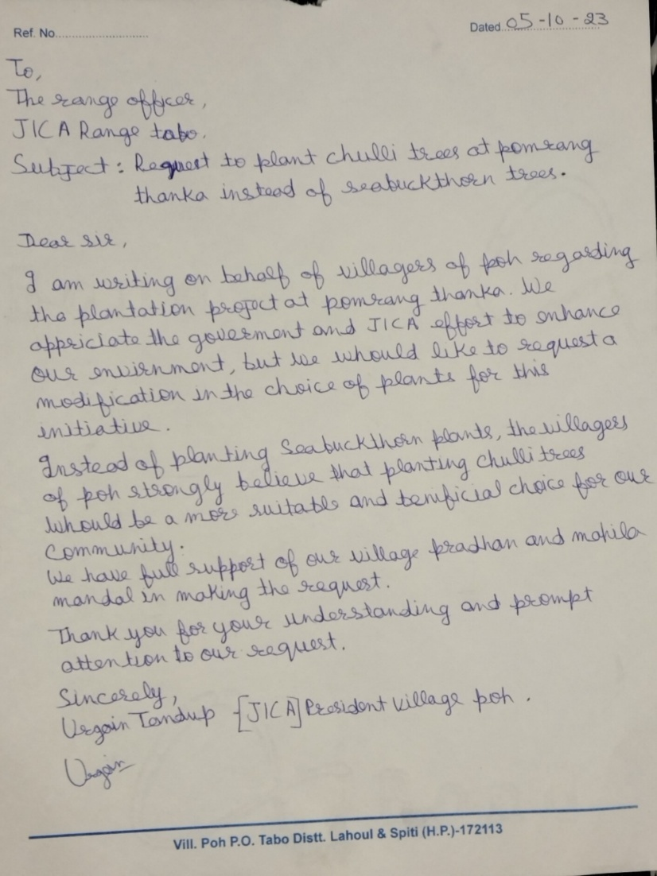

Plantation area: 9.36 Ha
Plantation norm: Afforestation @1100normal plants/Ha

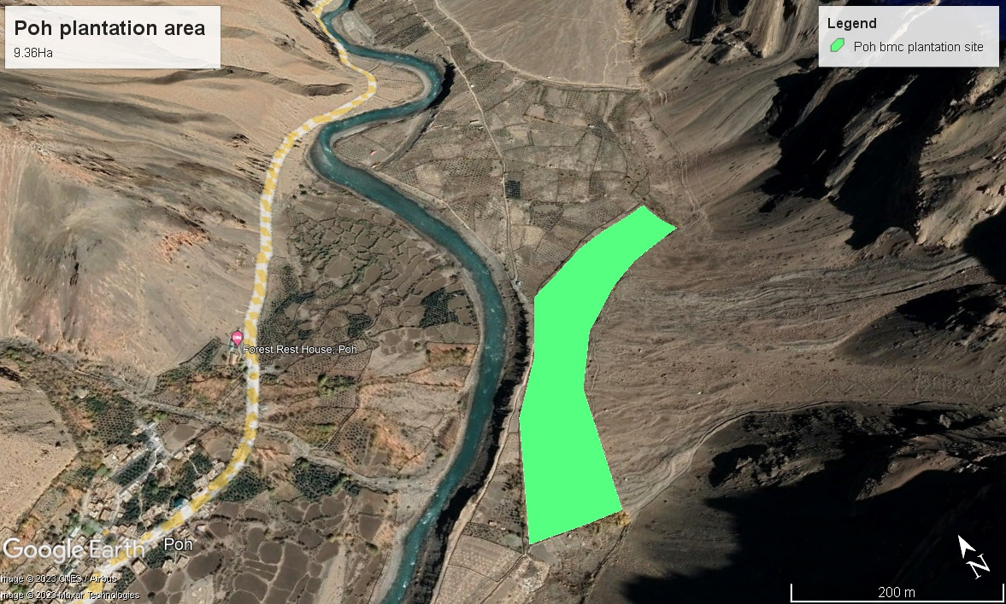

S.N. | Activity | Benefitting HHs | Area to be covered (Ha)
 |  |  | 2023-24 | 2024-25 | 2025-26 | 2026-27 | 2027-28
1 | Afforestation @1100plants/Ha Normal plantation | Whole community | - | 9.36 Ha  (Advance work and Plantation) | Maintenance | Maintenance | Maintenance

8.3 Requirements of Planting Materials
Year | Number of saplings required |  |  |  |  |  | Source of planting material
 | Populus ciliata |  | Salix spp. |  | Hippophae Spp. |  | Shego/Schichling Nursery
 | New | Maintenance | New | Maintenance | New | Maintenance
2023-24 | 780 |  | 1180 |  | 760
2024-25 |  | 234 |  | 354 |  | 228
2025-26 |  | 152 |  | 236 |  | 152
2026-27 |  | 114 |  | 177 |  | 114
2027-28 |  | 76 |  | 118 |  | 76
Total | 780 | 576 | 1180 | 885 | 760 | 570

8.4 ForestProtection/Silviculture/MaintenanceoperationforthePlantation
Year | Number of saplings required |  | Source of planting material
 | Prunus armeniaca (wild apricot)
 | New | Maintenance
2023-24 | - | - | Shego/Schichling Nursery
2024-25 | 10,296 |  | -do-
2025-26 |  | 3,089(30% of new) | -do-
2026-27 |  | 2,059 (20% of new0 | -do-
2027-28 |  | 1,030 (10% of new) | -do-
Total | 10,296 | 6,178

8.5 Plantation Activity under PFM Mode

Years | Activities to be taken up site |  | Responsibility
 | Poh (total plantation area = 9.36 ha |  | Project | Subcommittee
2023-24 | - | - | Yes | Yes
2024-25 | Plantation  (10,296 Saplings) |  | Yes | Yes
2025-26 | - | Maintenance (30% beating up) | Yes | Yes
2026-27 | - | Maintenance 20% beating up) | Yes | Yes
2027-28 | - | Maintenance 10% beating up) | Yes | Yes

8.6 Soil and water conservation

8.6.1 Soil and Water Conservation Works (Proposed)
S.N. | Type of SWC work | Unit of work | Quantum of work | HH beneficiaries | Responsibility
 |  |  |  |  | Project | Sub committee | Convergence
1 | Construction of contour trenches | ha | 9.36 | Whole community |  | Implementation and management
2 | Construction of crate wall (60Rmt) | No. | 1 | Whole community |  | Implementation and management

8.6.2 Soil and Water Conservation works (Year wise Physical Target)
S.N. | Type of SWC work | Unit of work | Quantum of work | HH beneficiaries | Physical target for SWC activities
 |  |  |  |  | 2023-24 | 2024-25 | 2025-26 | 2026-27 | 2027-28
1 | Construction of contour trenches | ha | 9.36 | Whole community | 0 | 4,680 | 0 | 0 | 0
2 | Construction of crate wall (60Rmt) | No. | 1 | Whole community | 0 | 1 | 0 | 0 | 0

8.7 Physical and Financial Plan (FEMP)

8.7.1 Proposed physical and financial plan
S.N. | Proposed Activity |  |  | Unit Cost |  | 2023-24 |  |  | 2024-25 |  |  |  | 2025-26 |  |  | 2026-27 |  |  | 2027-28 |  |  |  | Total
1 | New plantations |  |  |  |  | phy | fin |  | phy |  | fin |  | phy |  | fin | phy | fin |  | phy |  | fin |  | Phy |  | Fin
a | Afforestation @1100 normal plants/Ha |  |  | 68,600/Ha |  | 0 | 0 |  | 9.36ha |  | 6,42,096 |  | 0 |  | 0 | 0 | 0 |  | 0 |  | 0 |  | 9.36ha |  | 6,42,096
A | Total new plantations (A) |  |  |  |  |  |  |  | 9.36ha |  | 6,42,096 |  |  |  |  |  |  |  |  |  |  |  | 9.36ha |  | 6,42,096
 |  |  |  | Unit Cost |  | 2023-24 |  |  | 2024-25 |  |  |  | 2025-26 |  |  | 2026-27 |  |  | 2027-28 |  |  |  | Total
a | Afforestation @1100 normal plants/Ha (Maintenance) |  |  |  |  | phy | fin |  | phy |  | fin |  | phy |  | fin | phy | fin |  | phy |  | fin |  | Phy |  | Fin
i | 1st.YearMaint. (6250/Ha.) |  |  | 10,000 |  |  |  |  |  |  |  |  | 9.36 |  | 93,600 |  |  |  |  |  |  |  | 9.36 |  | 93,600
ii | 2nd Year maint.(4250/ha) |  |  | 6,700 |  |  |  |  |  |  |  |  |  |  |  | 9.36 | 62,712 |  |  |  |  |  | 9.36 |  | 62,712
iii | 3rd year maint.(3200/ha) |  |  | 5,100 |  |  |  |  |  |  |  |  |  |  |  |  |  |  | 9.36 |  | 47,736 |  | 9.36 |  | 47,736
iv | 4th year maint.(2200/ha) |  |  | 3,500
v | 5th year maint.(2200/ha) |  |  | 3,500
 | Total (B) |  |  |  |  |  |  |  |  |  |  |  |  |  | 93,600 |  | 62,712 |  |  |  | 47,736 |  |  |  | 2,04,048
 | Sub Total (A+B) |  |  |  |  |  |  |  |  |  | 6,42,096 |  |  |  | 93,600 |  | 62,712 |  |  |  | 47,736 |  |  |  | 8,46,144
S.N. | Proposed Activity | Unit Cost | 2023-24 |  |  |  |  | 2024-25 |  |  |  | 2025-26 |  |  |  | 2026-27 |  |  |  | 2027-28 |  |  |  | Total
 | SMC Trenching |  | phy |  | fin |  |  | phy |  | fin |  | phy |  | fin |  | phy |  | fin |  | phy |  | fin |  | phy |  | fin
1. | SMC works (Preparation of contour trenches) | 15,750/Ha |  |  |  |  |  | 9.36 |  | 1,47,420 |  |  |  |  |  |  |  |  |  |  |  |  |  | 9.36 |  | 1,47,420
 | Soil and water conservation |  | phy |  | fin |  |  | phy |  | fin |  | phy |  | fin |  | phy |  | fin |  | phy |  | fin |  | phy |  | fin
1. | Construction of crate wall (60Rmt) | 5,833/  Rmt |  |  |  |  |  | 60Rmt |  | 3,50,000 |  |  |  |  |  |  |  |  |  |  |  |  |  | 60Rmt |  | 3,50,000
 | Total (C) |  |  |  |  |  |  |  |  | 4,97,420 |  |  |  |  |  |  |  |  |  |  |  |  |  |  |  | 4,97,420
 | Grand Total (A+B+C+ |  |  |  |  |  |  |  |  | 11,39,516 |  |  |  | 93,600 |  |  |  | 62,712 |  |  |  | 47,736 |  |  |  | 13,43,564

8.7.2 Annual Work Plan for 2024-2025
S.N | Proposed activity | Benefitting HH | Unit of work | Quantum of work |  |  | Financial source
 |  |  |  |  | Unit cost (Rs) | proposed budget | project | convergence | community contribution
New plantations
1 | Afforestation @1100 normal plants/Ha | whole community | ha | 9.36 | 68,600 | 6,42,096 | project |  | management
 | Total |  |  |  |  | 6,42,096
soil and water conservation
1. | Contour trenches | whole community | ha | 9.36 | 15,750 | 1,47,420 | project |  | management
2. | Construction of crate wall (60Rmt) | whole community | Rmt | 60Rmt | 5,833 | 3,50,000 | project |  | management
 | Total |  |  |  |  | 4,97,420
 | Sub total |  |  |  |  | 11,39,516

9. A BRIEF APPROACH OF SATOYAMA UNDER THIS PROJECT

Satoyama is a traditional Japanese concept that refers to a unique and sustainable approach to managing rural landscapes. The term "satoyama" literally translates to "sato" (village) and "yama" (mountain), signifying the harmonious coexistence of human settlements and the surrounding natural environment. Satoyama landscapes are characterized by a balanced relationship between agriculture, forestry, and the preservation of biodiversity.
Here is some brief information about Satoyama:
- Ecological Harmony: Satoyama landscapes are designed to maintain a delicate balance between human activities and the natural world. This balance is achieved by sustainable farming practices, including crop cultivation, livestock rearing, and forestry.
- Biodiversity Conservation: Satoyama areas often contain diverse ecosystems with a wide variety of plant and animal species. Local communities play a crucial role in preserving these ecosystems, which can support both wildlife and human needs.
- Cultural Significance: Satoyama landscapes are deeply rooted in Japanese culture and history. They are often associated with traditional agricultural practices, festivals, and communal activities that have been passed down through generations.
- Community Involvement: Local communities in satoyama areas actively participate in the management and conservation of their natural resources. This involvement helps foster a sense of responsibility and pride in maintaining the balance between human activities and nature.
- Economic Sustainability: The sustainable management of satoyama landscapes not only supports the environment and culture but also contributes to the economic well-being of rural communities. It provides livelihoods for people engaged in farming, forestry, and related industries.
- Challenges: Despite their importance, many satoyama landscapes face challenges due to urbanization, depopulation of rural areas, and changes in land use. Conservation efforts and policies are being implemented to protect and revitalize these valuable landscapes.
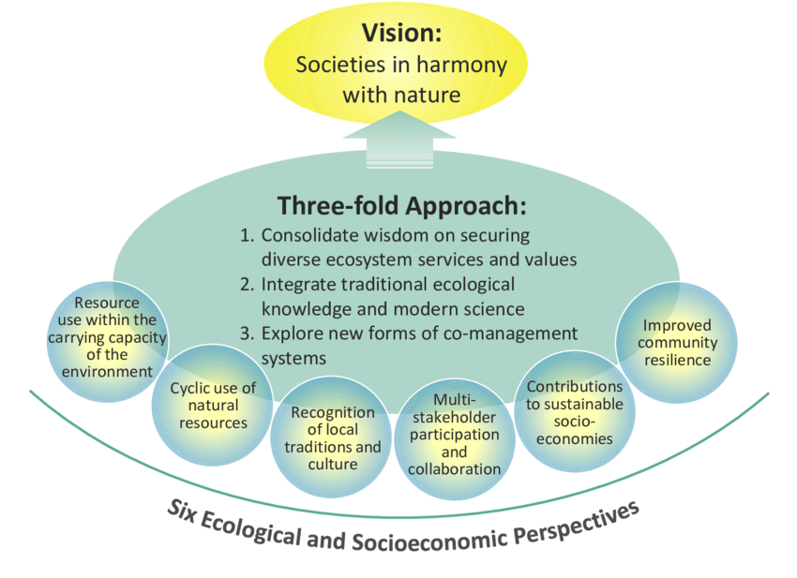

Schematic Diagram of Satoyama Initiative

Satoyama serves as an inspiring example of how humans can live in harmony with nature, maintaining both ecological and cultural diversity. It represents a holistic approach to land use and conservation that can provide valuable lessons for sustainable development and environmental stewardship worldwide.

The implementation of the Satoyama concept in a JICA (Japan International Cooperation Agency) project for the improvement of Himachal Pradesh's forest ecosystem management and livelihoods would involve applying the principles of Satoyama to the specific context and needs of the region. Here's how it could be implemented and why it's important:
Implementation:
- Assessment and Planning: The project would start with a comprehensive assessment of the current state of Himachal Pradesh's forest ecosystems and the livelihoods of the communities dependent on them. This assessment would identify areas where the Satoyama approach could be applied effectively.
- Community Engagement: Engaging with local communities is a fundamental aspect of Satoyama. The project would involve communities in decision-making processes, ensuring that their traditional knowledge and practices are integrated into conservation and livelihood improvement efforts.
- Sustainable Forest Management: Himachal Pradesh has significant forest resources. Implementing sustainable forestry practices, such as selective logging and reforestation, would be crucial to maintaining ecological balance and ensuring a long-term supply of forest products.
- Biodiversity Conservation: Efforts would be made to protect and enhance biodiversity within the forest ecosystems. This might include the establishment of protected areas and the promotion of habitat restoration practices.
- Agricultural Practices: Like in traditional Satoyama landscapes, the project could promote sustainable agricultural practices that reduce the environmental impact, such as organic farming and agroforestry.
- Livelihood Diversification: Recognizing that communities often rely on a combination of activities for their livelihoods, the project could support the diversification of income sources, such as promoting ecotourism, cottage industries, and non-timber forest product harvesting.
- Capacity Building: Training and capacity-building programs would be essential to equip local communities with the skills and knowledge needed to manage their resources sustainably.
- Traditional values: Indigenous and local communities in Himachal Pradesh have valuable traditional knowledge related to agriculture, forestry, and resource management. The Satoyama Initiative aims to preserve and integrate this knowledge into sustainable practices.

Comparison of rational for Satoyama initiatives in Himachal Pradesh
JAPAN | HIMACHAL PRADESH
- 68% of total geographical area is under forest cover. | - 27.72% of total geographical area is under forest.
- Maximum forest land is owned privately | - Maximum forest area is government owned
- Natural Resource depletion is due to depopulation and under use of natural resources(forests) | - Natural Resource depletion is because of overuse of forest resources
- Migration of rural population to urban areas | - Trend in urbanization is on rise
- It aims to bring back people towards forests to manage forests | - It aims to enable human interface for sustainable management of forest resources and minimise migration of people from villages to urban areas

Importance:
- Conservation of Biodiversity: Implementing the Satoyama approach in Himachal Pradesh would help conserve its rich biodiversity, protecting endangered species and preserving the ecological balance of the region.
- Sustainable Resource Management: Himachal Pradesh's forests are critical for the well-being of both nature and local communities. Sustainable resource management would ensure a continuous supply of forest products and protect against deforestation and environmental degradation.
- Community Empowerment: Engaging local communities in decision-making and resource management empowers them to take ownership of their environment, leading to more effective conservation and improved livelihoods.
- Cultural Preservation: The project would help preserve the cultural and traditional practices of indigenous communities in Himachal Pradesh, which are often closely linked to their natural environment.
- Climate Resilience: Satoyama practices often enhance the resilience of ecosystems to climate change, making the region better prepared for future environmental challenges.
- International Collaboration: By implementing the Satoyama concept in Himachal Pradesh, India can benefit from Japan's experience and expertise in sustainable land management, fostering international cooperation and knowledge exchange.
In summary, implementing the Satoyama concept in a JICA project for the improvement of Himachal Pradesh's forest ecosystem management and livelihoods holds great promise for balancing the needs of people and nature in the region while promoting sustainable development and conservation.

Problem Analysis and Solution

Analysed Problems and Scientific Solutions
S.  No | Problems identified | Justification of problems identified | Extent of problems | Recommended solutions
1 | Depleting availability of medicinal plants and fodders from nearby forest area. | Due to limited forest area, the over exploitation and overgrazing causes the problem | Serious | Conservation of floral diversity through community approaches.  Plantation programs.
2 | Low moisture retention/water scarcity | The area is rainfed so limited water resources cause these problems. | Severe | Construction of water harvesting structures.
3 | Soil erosion | Due to glacier melt and wind. | Moderate | Contour trenching, construction of check dams/crate walls
4 | Inadequate supply of drinking water | Due to cold winter when temperature reaches below -25⁰ c then drinking water is not available | Severe | This issue should be addressed by government agencies.
5 | Marketing of Food/Value added Products | No marketing strategies for value added agricultural products. | Moderate | Capacity building/Trainings/workshops are necessary to solve these problems which should be lead by Agri/Horti department.
6 | Fertilizers/Seeds/FYM | Due to the remoteness of the area | Severe | This issue should be addressed by government agencies.

Perceived Problems and Solutions
S.  No | Key Stakeholders | Key problems identified by stakeholders | No of HHs and/or area affected | Critical causes of the problems | Perceived solutions
1 | Women | Low income, problems related to fodders and fuel wood, no equal rights for participation in community development activities | 80 | Lack of education and awareness | Education for women/girls, equal participation in community activities, rural entrepreneurship development through SHGs and Mahila mandal.
2 | Wage-  labour | No proper/promised employment, | 5 | Not much employment generation activities | Employment chances in agricultural activities/construction work and in other departments
3 | Farmer | Water scarcity, no proper marketing of agricultural products, less availability of improved seed and fertilizers. | 80 | Rainfed agriculture, tough terrains, long and harsh winter, not much support from agriculture/horticulture department | Water harvesting activities, plantation activities, capacity building programs on organic compost preparation and scientific/climate resilient agriculture

Community Development and Livelihood Improvement Plan

9.1Community Development Activities
S.N. | Activity | Purpose of the Activity | HHs to be benefited | Community Contribution
1 | Construction of irrigation Canals | Irrigation for Apple Orchards and Agricultural Land | Whole community | 10%
2 | Maintenance of Old Water bodies | Irrigation/Drinking Water | Whole Community | 10%
3 | Public dustbins (Dry and wet)/no. | For Sanitation/Beautification of Tourist area | Whole community | 10%
4 | Corals for livestock’s | Protection of livestock from snow leopards and feral dogs | Whole community | Maintenance
5 | Solar Hamam | Providing Warm Water during winters | Whole community | Maintenance
6 | Feral Dogs Sterilization | Control population of feral dogs` | Whole community | Maintenance
7 | Incentive to dog catcher | Control population of feral dogs` | Whole 8community | Maintenance
8 | Orientation workshop on crop damage protection from wildlife | Spreading awareness on Protection of crops from wildlife damage | Whole community | Maintenance
- Detailed estimation plan will be prepared by BMC Subcommittee with inputs from PMU/DMU/FTU and concerned departments if required.
- Community will be expected to contribute to activity costs in the form of labour, materials and cash.
- The BMC Subcommittee will be responsible for monthly monitoring and quality control of the work to be executed and the maintenance and management of the community assets created.
- Guidelines will be developed by the PMC for the performance, maintenance and management of community assets.

9.1.1Physical & Financial details of Community Development Works
S.N. | Proposed activities | Unit Cost |  | 2023-24 |  | 2024-25 |  | 2025-26 |  |  | Total unit | Total est. cost
 |  |  | Unit | Estimated cost Rs) | Unit |  | Estimated cost Rs) | Unit |  | Estimated cost Rs)
1 | Construction of irrigation canal/350 mtr. | 750mtr |  | - | - |  | - | 350mtr | 2,62,500 |  | 350 | 2,62,500
2 | Maintenance of Old Water bodies/no | 25000 |  | - | - |  | - | 3 | 75,000 |  | 3 | 75,000
3 | Public dustbins (Dry and wet)/no. | 15,000 |  | - | - |  | - | 5 | 75,000 |  | 5 | 75,000
4 | Corals for livestock’s | 15000 | - | - | 7 |  | 1,05,000 | 7 | 1,05,000 |  | 14 | 2,10,000
5 | Solar Hamam | 15000 | 5 | 75000 |  |  |  |  |  |  | 5 | 75000
6 | Feral Dogs Sterilization | 100000 |  |  |  |  |  | L/S | 2,00,000 |  | L/S | 2,00,000
7 | Incentive to dog catcher | 10000 |  |  |  |  |  | 10 | 1,00,000 |  | 10 | 1,00,000
8 | Orientation workshop on crop damage protection from wildlife | 10,000 |  |  | 1 |  | 10,000 |  |  |  | 1 | 10,000
9 | Gazebo tent for SHGs | 25,000 |  |  |  |  |  | 1 | 25,000 |  | 1 | 25,000
 | Total |  |  | 75,000 |  |  | 1,15,000 |  | 8,42,500 |  |  | 10,32,500

9.2Livelihood Improvement/Income Generation Activities (IGAs)
S.N. | Activity | No. of SHGs to be covered/benefitting households | Members to be Covered |  | Availability to key inputs (YES/No) |  |  |  | Expected Funds (Rs) | Expected Profitability (Rs) | Beneficiary Contribution (%)
 |  |  | Male | Female | Skills | Raw Material | Technology | Market
1 | Capacity building/Training on agricultural activities | Whole community | Whole community |  | No | Yes | No | Yes | 1,00,000
2 | Value Addition and marketing trainings related to IGA-cum-  Exposure visit for SHG members | 2 SHGs | Self help group members |  | Yes | No | Yes | Yes | 5,00,000
 | Total |  |  |  |  |  |  |  | 6,00,000

- Major livelihood activities emerged during micro planning process included Hand Knitting/Khadi for SHG along with mushroom cultivation, fruit processing, preservation and value addition.
- Livelihood activities will be implemented through self-help groups (SHG).
- The SHG will have 8-20 members.
- In addition to regular group savings of Rs. 1 lakh will be provided as grant for revolving fund Focus will be on linking SHGs with banks
- Banks may consider loan of 3-4 times of the savings and deposits of the SHG
- The technical feasibility and economic viability of the proposed livelihood activities will be considered. Business plan will be prepared for each activity.
- The livelihood improvement scheme at the ward level will be linked to the cluster for procurement, marketing and technical advice.
- Guidelines to be developed by PMC for implementation of livelihood improvement activities.

9.3Proposed Physical and financial coverage of livelihood improvement and Income Generation Activities
S. N | Activity | Target Group | Unit Cost | 2023-24 |  | 2024-25 |  | 2025-26 |  | Total
 | Proposed Physical and financial coverage of livelihood improvement and Income Generation Activities |  |  | phy | fin | phy | fin | phy | fin | phy | fin
1 | Capacity building/Training on agricultural activities | Whole community | 100000 | 0 | - | 1 | 1,00,000 | 0 | 0 | 1 | 100,000
2 | Value Addition and marketing trainings related to IGA-cum-  Exposure visit for SHG members | Self-help group members | 5,00,000 |  |  |  |  | 1 | 5,00,000 | 2 | 5,00,000
Total |  |  |  |  |  |  | 1,00,000 |  | 5,00,000 |  | 6,00,000

9.4 Formation of SHGs
Year | No. of SHGs | Members
 |  | Male | Female | Total
2016 | 2 | 0 | 24 | 24
2023-24 | - | - | - | -
2024-25 | - | - | - | -
2 SHGs are being formed in the BMC Poh, namely Thunlam (13 members) and Lhayul (11 members)

9.5Annual Work Plan for Community Development and Livelihood Improvement (CD&LIP)
S.N. | Proposed Activity | SHGs | No. of Beneficiary | Proposed Budget | Financial source
 | Community Development |  |  |  | Project | convergence | Community contribution
a. | Construction of wire crate protection for village agricultural land | - | Whole community | 5,00,000 | 5,00,000 | - | -
 | total |  |  | 5,00,000 | 5,00,000 | - | -
 | Livelihood Improvement
a. | Capacity building/Training on agricultural activities |  | Whole community | 100,000 | 100,000 | 0 | 0
b. | Value Addition and marketing trainings related to IGA-cum-  Exposure visit for SHG members | 2 | - | 5,00,000 | 5,00,000
 | total |  |  | 6,00,000 | 6,00,000 | - | -
 | Total |  |  | 11,00,000 | 11,00,000 | - | -

10. Activities identified in Poh BMC
Activities to be carried out with the support of other Departments/ Projects/ Schemes Community Infrastructure development, basic human needs, agriculture and horticulture, IPH, Jal Shakti (through convergence)

10.1 Activities identified and implementing agencies
S.N. | Activities | HHs to be benefitted | Implementing agency | Proposed Budget (Rs)
1 | Plantation (Afforestation @1100 normal plants/Ha | Whole community | Forest department | 6,42,096
2 | Maintenance of new plantation | Whole community | Forest department | 2,04,048
3 | Contour trenches | Whole community | Forest department | 1,47,420
4 | Construction of crate wall (60Rmt) | Whole community | Forest department | 3,50,000
5 | Construction of wire crate protection for village agricultural land | Whole community | Forest department | 5,00,000
6 | Construction of irrigation canal/350 mtr. | Whole community | Forest department | 2,62,500
7 | Maintenance of Old Water bodies/no | Whole community | Forest department | 75,000
8 | Public dustbins (Dry and wet)/no. | Whole community | Forest department | 75,000
9 | Corals for livestock’s | Whole community | Forest department | 2,10,000
10 | Solar Hamam | Whole community | Forest department | 75,000
11 | Feral Dogs Sterilization | Whole community | Forest department | 2,00,000
12 | Incentive to dog catcher | Whole community | Forest department | 1,00,000
13 | Orientation workshop on crop damage protection from wildlife | Whole community | Forest department | 10,000
14 | Gazebo tent for SHGs | SHG members | Forest department | 25,000
15 | Capacity building/Training on agricultural activities | Whole community | Forest department | 1,00,000
16 | Value Addition and marketing trainings related to IGA-cum-  Exposure visit for SHG members | SHG members | Forest department | 5,00,000
 | TOTAL |  |  | 34,76,064

10.2 Proposed Physical & Financial Coverage of Convergence Activities
S.N. | Activity |  |  | Unit Cost | 2023-24 |  |  | 2024-25 |  | 2025-26 |  | 2026-27 |  | 2027-28 |  | Total
 |  | Proposed Physical & Financial Coverage of Convergence Activities |  |  |  | phy | fin | phy | fin | phy | fin | phy | fin | phy | fin | phy | fin
1 |  | Plantation | 68,600/Ha |  |  |  |  | 9.36ha | 6,42,096 |  |  |  |  |  |  | 9.36ha | 6,42,096
2 |  | Maintenance | 10,000/ha (1st yr)  6,700/ha (2nd yr)  5100/ha (3rd yr) |  |  |  |  |  |  | 9.36ha | 93,600 | 9.36ha | 62,712 | 9.36ha | 47,736 | 9.36ha | 2,04,048
3 |  | Contour trenches | 15,750 |  |  |  |  | 9.36Ha | 1,47,420 |  |  |  |  |  |  | 9.36Ha | 1,47,420
4 |  | Construction of crate wall (60Rmt) | 5,833Rmt |  |  |  |  | 60Rmt | 3,50,000 |  |  |  |  |  |  | 60Rmt | 3,50,000
5 |  | Construction of wire crate protection for village agricultural land | 5,00,000 |  |  | 1 | 2,50,000 |  | 2,50,000 |  |  |  |  |  |  | 1 | 5,00,000
6 |  | Construction of irrigation canal/350 mtr. | 750/mt |  |  |  |  |  |  | 350mtr | 2,62,500 |  |  |  |  | 200mt | 2,62,500
7 |  | Maintenance of Old Water bodies/no | 25,000 |  |  |  |  |  |  | 3 | 75,000 |  |  |  |  | 3 | 75,000
8 |  | Public dustbins (Dry and wet)/no. | 15,000 |  |  |  |  |  |  | 5 | 75,000 |  |  |  |  | 5 | 75,000
9 |  | Corals for livestock’s | 15000 |  |  |  |  | 7 | 1,05,000 | 7 | 1,05,000 |  |  |  |  | 14 | 2,10,000
10 |  | Solar Hamam | 15000 |  |  | 5 | 75,000 |  |  |  |  |  |  |  |  | 5 | 75,000
11 |  | Feral Dogs Sterilization | 100000 |  |  |  |  |  |  | L/S | 2,00,000 |  |  |  |  | L/S | 2,00,000
12 |  | Incentive to dog catcher | 10000 |  |  |  |  |  |  | 10 | 1,00,000 |  |  |  |  | 10 | 1,00,000
13 |  | Orientation workshop on crop damage protection from wildlife | 10,000 |  |  |  |  | 1 | 10,000 |  |  |  |  |  |  | 1 | 10,000
14 |  | Gazebo tent for SHGs | 25,000 |  |  |  |  |  |  | 1 | 25,000 |  |  |  |  |  | 25,000
15 |  | Capacity building/Training on agricultural activities | 1,00,000 |  |  |  |  | 1 | 1,00,000 |  |  |  |  |  |  | 1 | 1,00,000
16 |  | Value Addition and marketing trainings related to IGA-cum-  Exposure visit for SHG members | 5,00,000 |  |  |  |  |  |  | 1 | 5,00,000 |  |  |  |  |  | 5,00,000
 |  | Total |  |  |  |  | 3,25,000 |  | 16,04,516 |  | 14,36,100 |  | 62,712 |  | 47,736 |  | 34,76,064

11. Implementation Strategies

11.1 Implementation guidelines on components and sub-components
- Participatory forest management
- Soil & water conservation/landslide control measures
- Community development and livelihood improvement with gender
Mainstreaming

11.2 Training and capacity building of community institutions (BMC Subcommittee, SHG)
Institution | Areas of training/Capacity Building | Resource Person/group | Location for exposure visit
BMC-Executive committee | Proceeding writing  Account maintaining  Inventory of Assets  created  Role & responsibility  of EC | JICA Staff/  Forest Department  staff/ Consultant | Dehradun, Chamba,  Kangra, Solan
SHG | Group formation,  Account maintaining,  Proceeding writing, Bank  linkages etc. | NABARD/Master trainer | -

11.3 Year wise detail of training and capacity building plan
S.N. | Year | Community institution | Subject of training | Number of participants | Duration | Resource person/group
1 | 2023-24 | BMC Subcommittee (Executive committee) | Proceeding writing  Account maintaining  Role & responsibility of EC  Gender  Group formation and inter loaning in SHG | 7-15  (EC Representative) | 2 days | Master trainer  FD accountants
2 | 2023-24 | EC and SHG training | M&E /Social audit  Assets created | 3-5 | 1 day | FTU Coordinators

11.4 Proposed year wise trainings/ capacity building of community institutions
Proposed activities | Unit | Total |  | 2022-23 |  | 2023-24 |  | 2024-25 |  | 2025-26 |  | 2026-27
Training and Capacity Building of Community Institutions |  | phy | fin | phy | fin | phy | fin | phy | fin | phy | fin | phy | fin
Subcommittee (EC) training
a) Proceeding account  Maintain | no. | 2 | 0 | 1 | 0 | 0 | 0 | 1 | 0 | 0 | 0 | 1 | 0
b) Role Responsibility,  Gender, Assets  created | no. | 3 | 0 | 1 | 0 | 1 | 0 | 1 | 0 | 0 | 0 | 1 | 0
c) M&E and Audit | no. | 4 | 0 | 1 | 0 | 1 | 0 | 1 | 0 | 1 | 0 | 1 | 0
Sub total |  | 9 | 0 | 3 | 0 | 2 | 0 | 3 | 0 | 1 | 0 | 3 | 0
SHG Training
a) Group formation, proceeding writing | no. | 2 | 0 | 1 | 0 | 1 | 0 | 0 | 0 | 0 | 0 | 0 | 0
b) Account Maintain, Bank  Linkages etc. | no. | 2 | 0 | 1 | 0 | 1 | 0 | 0 | 0 | 0 | 0 | 0 | 0
Sub total |  | 4 | 0 | 2 | 0 | 2 | 0 | 0 | 0 | 0 | 0 | 0 | 0

11.5 Records to be maintained by the Community Institution
S.N. | Name of the record/register to be maintained | To be maintained by whom | To be verify by whom
1 | Membership register, bye laws, & other records | President / Member Secretary VFDS | FTU Officer/FTU Coordinator
2 | Proceeding register | Member Secretary VFDS/Joint Secretary | FTU Coordinator
3 | Cash account register & related books | Treasurer, Secretary, joint Secretary | FTU Officer/FTU Coordinator
4 | Asset created register | President, Secretary | FTU/Project representatives

ANNEXURES

Annexure-I

Social map of Poh BMC Subcommittee

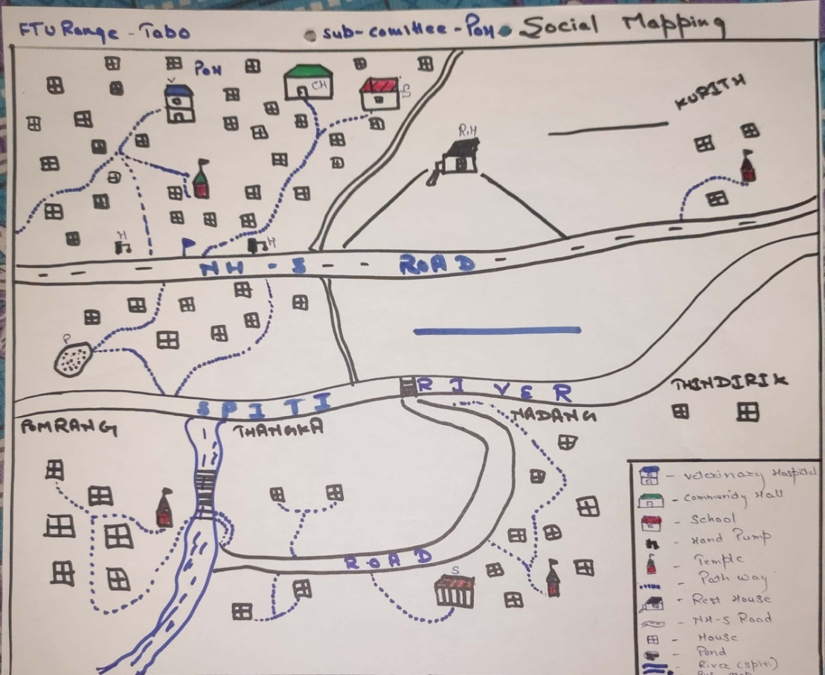

Annexure-II

Resource map of Poh BMC Sub Committee
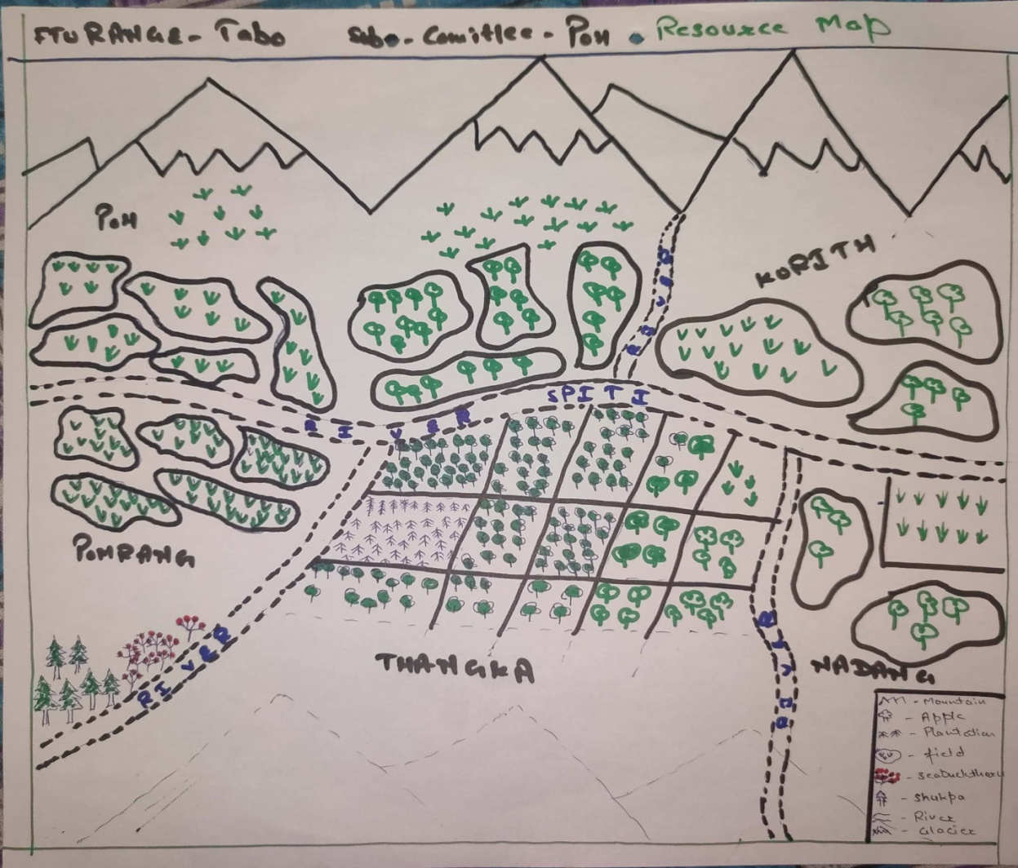

Annexure-III

Aerial image map: Survey & Mapping of Intervention area
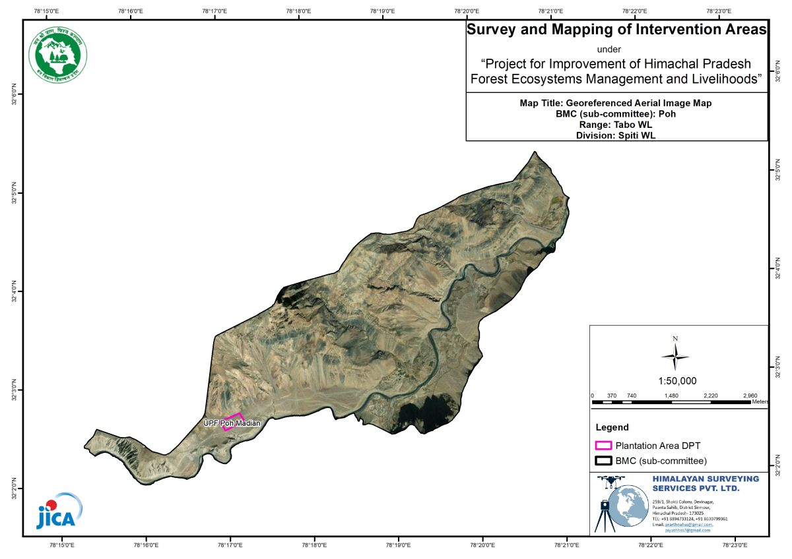

Annexure-IV

Contour Map: Survey & Mapping of Intervention Area
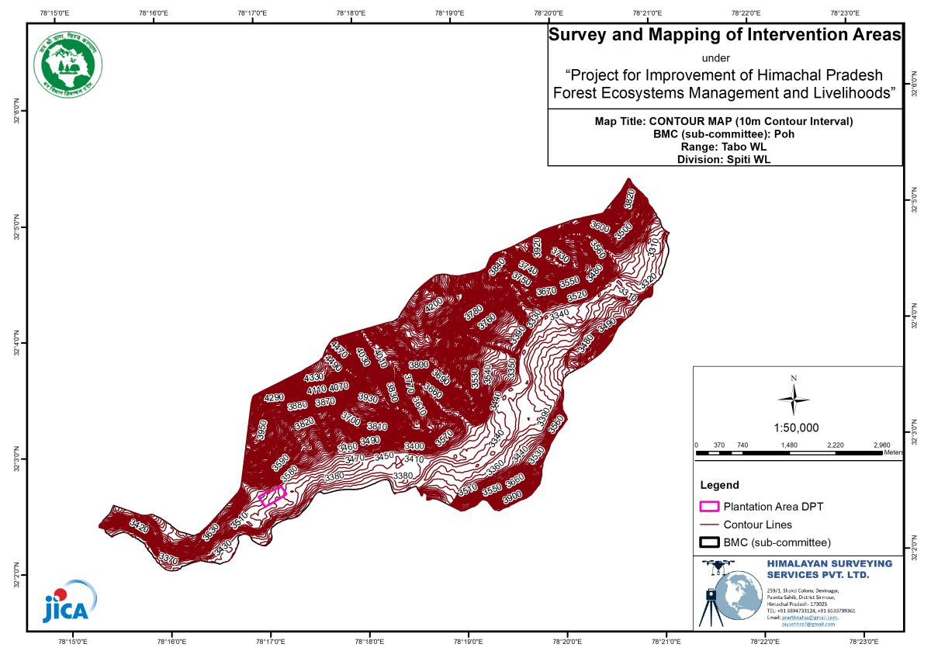

Annexure-V

Land Use Cover Map: Survey & Mapping of Intervention Area

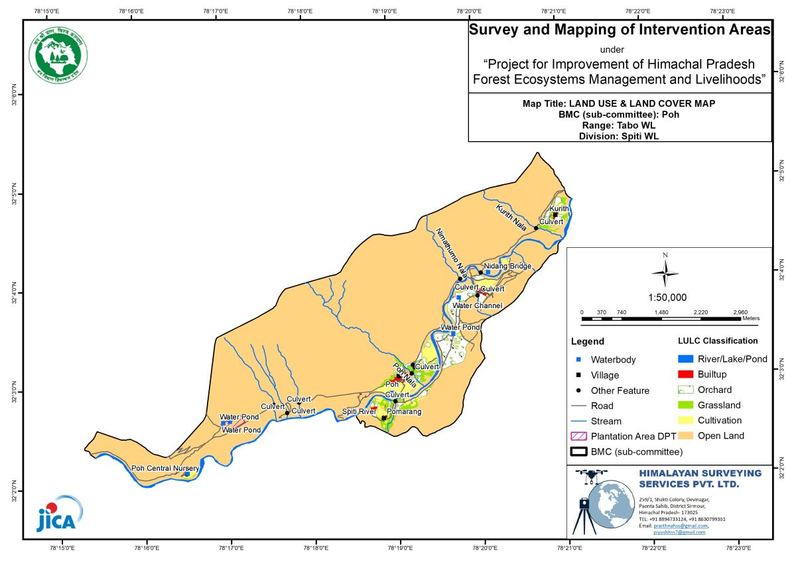
Annexure VI

Forest Cover Map: Survey & Mapping of Intervention Area
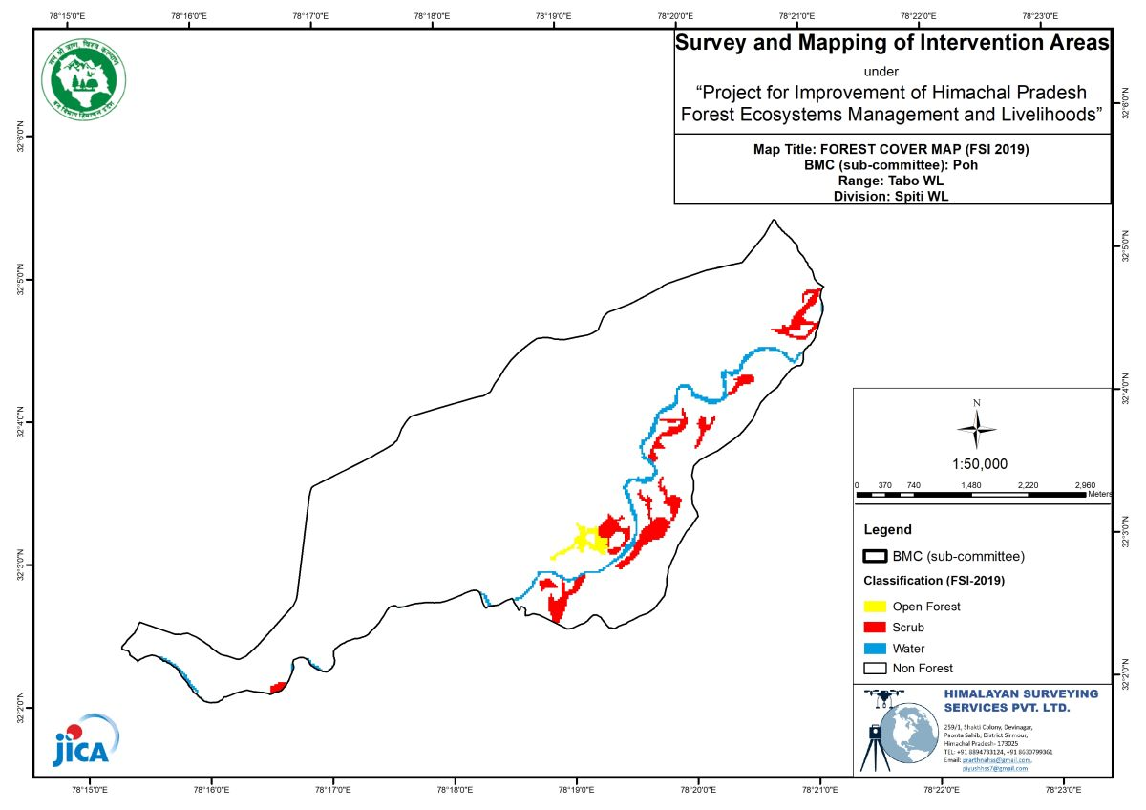

Annexure VII

Copy of the proceedings of the general body:
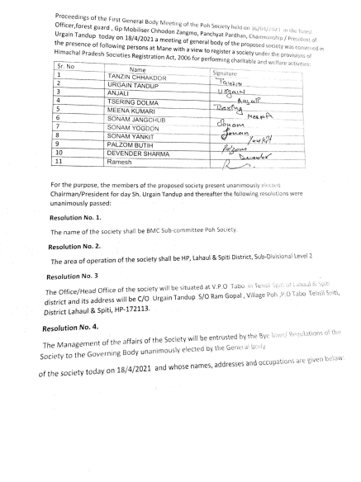

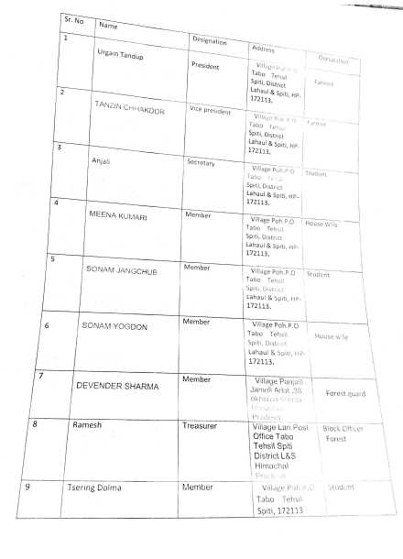

Annexure VIII

Panchayat resolution copy:
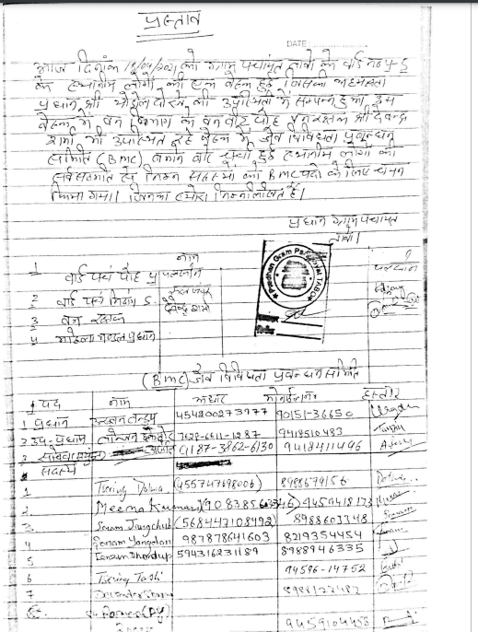

Annexure IX

Joint Declaration from Promoter Members

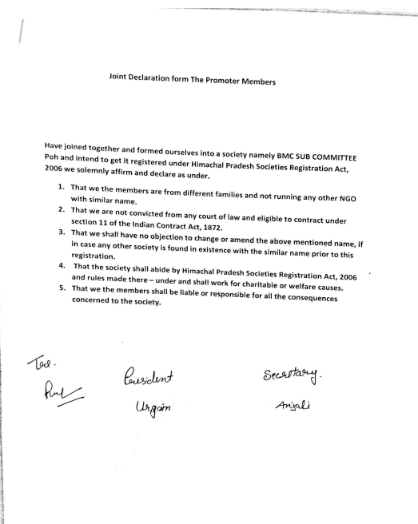

Annexure X

MoU between DMU and President BMC Subcommittee copy:



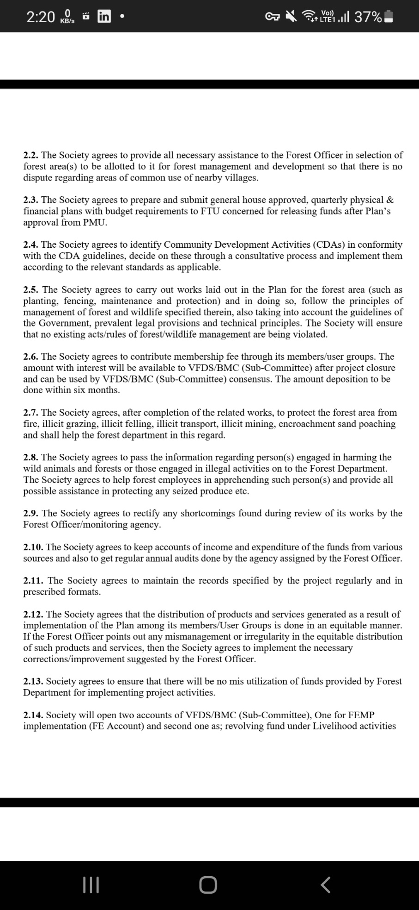


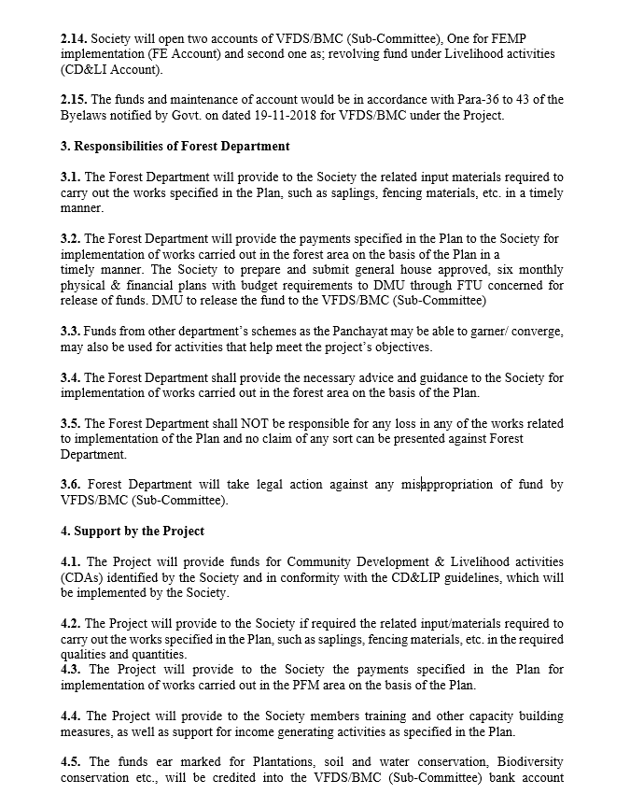

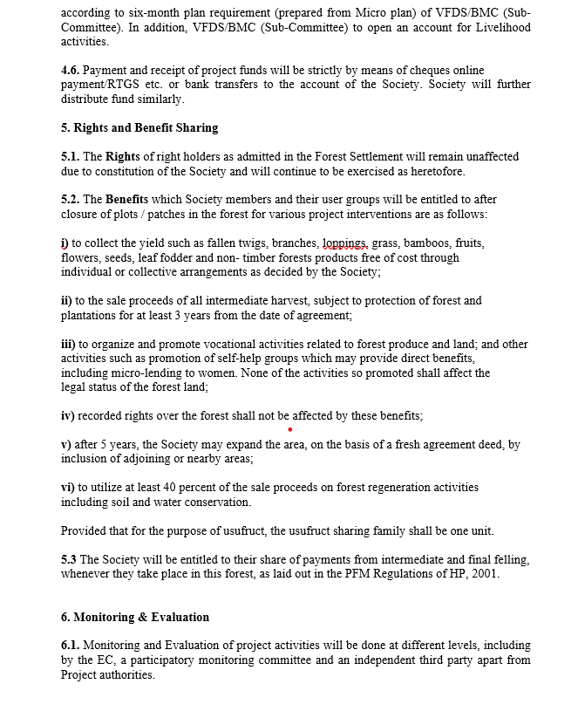



Annexure XI

Certificate of Registration of the BMC Subcommittee
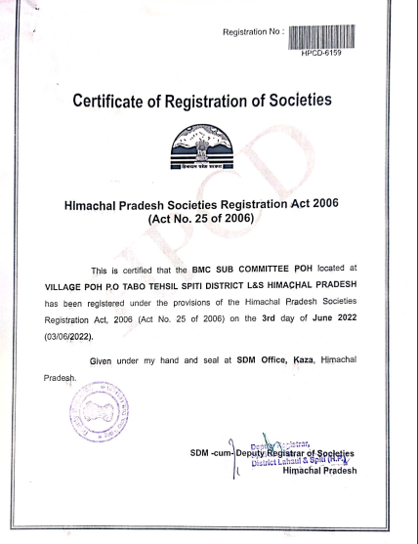

Annexure XII

Copy of Bylaws

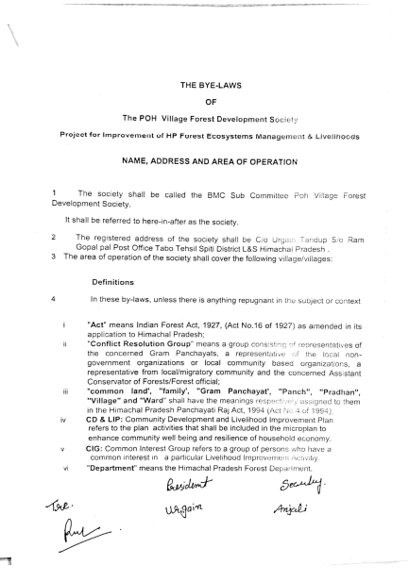

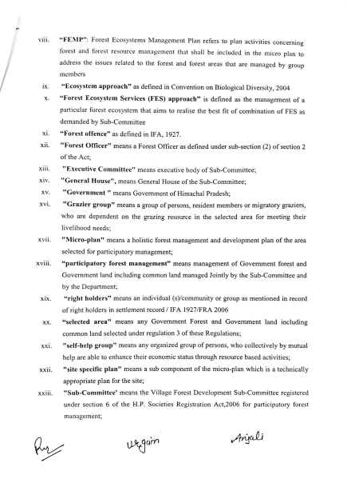






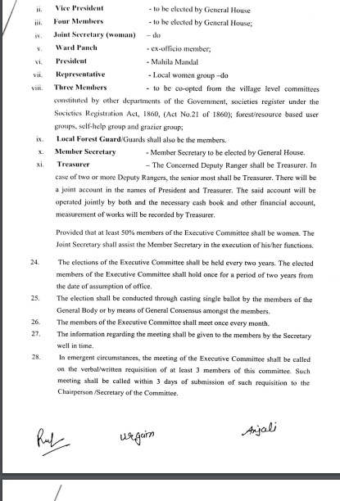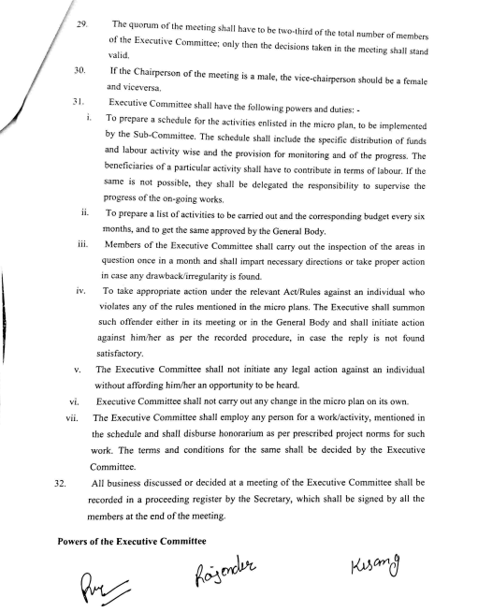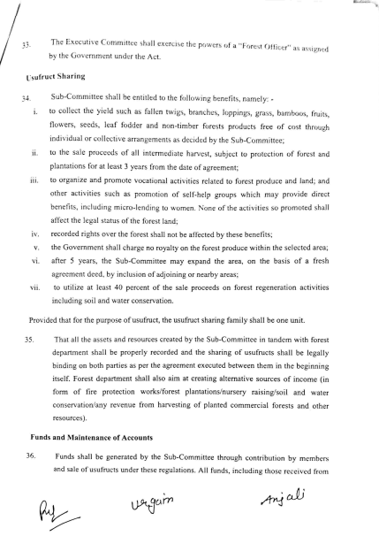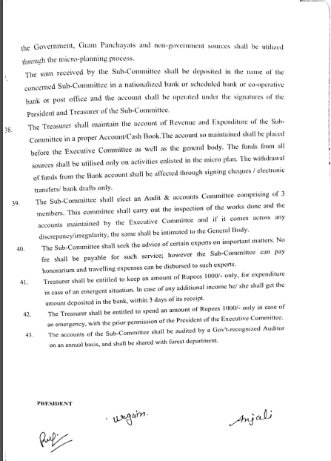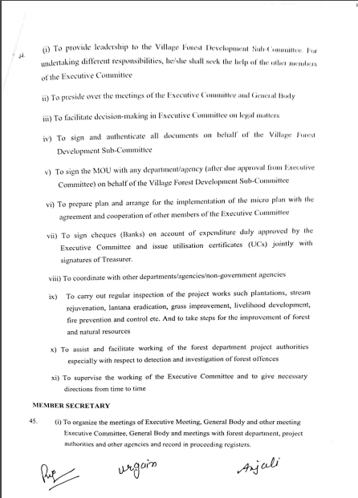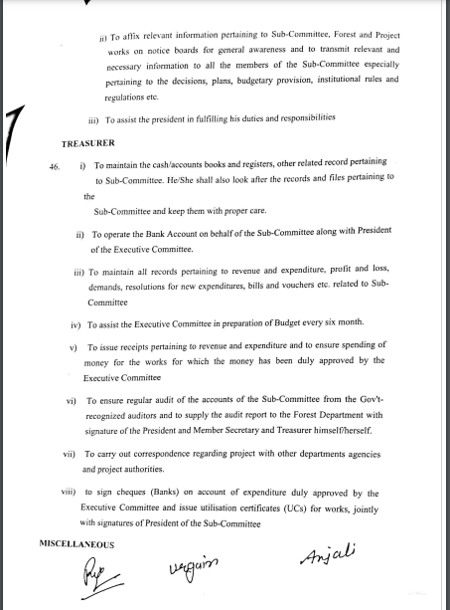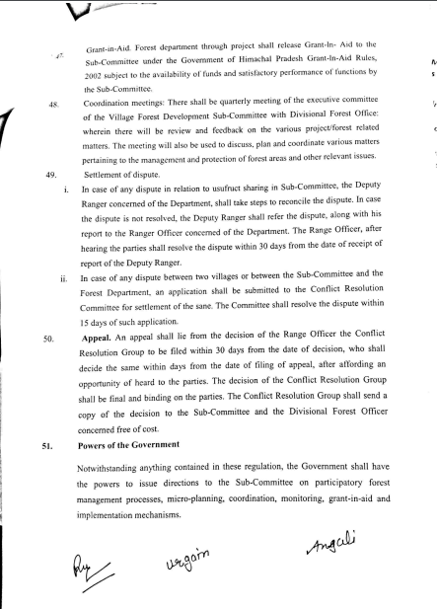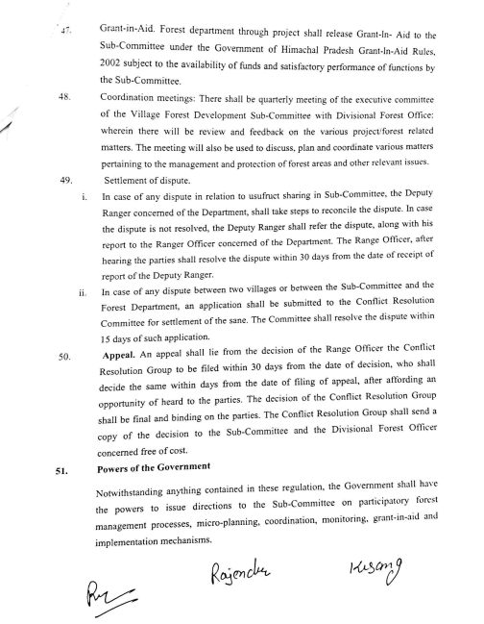
\

Annexure XIII

Photos during Micro Planning Process

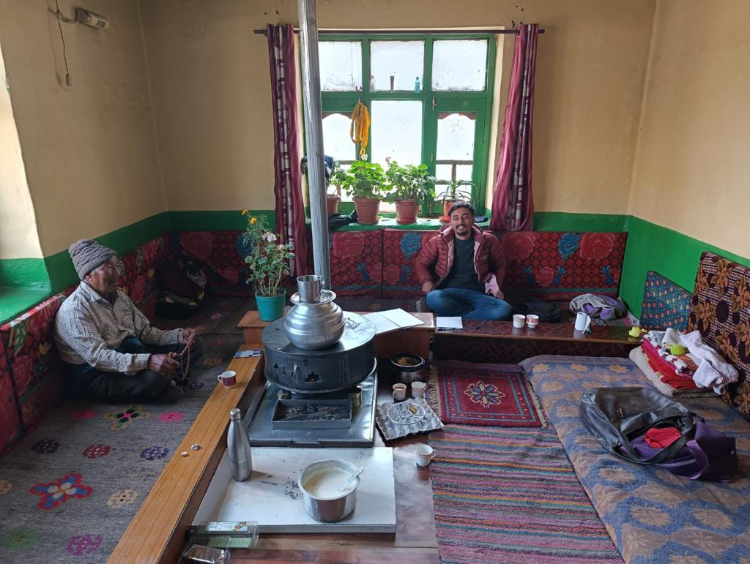

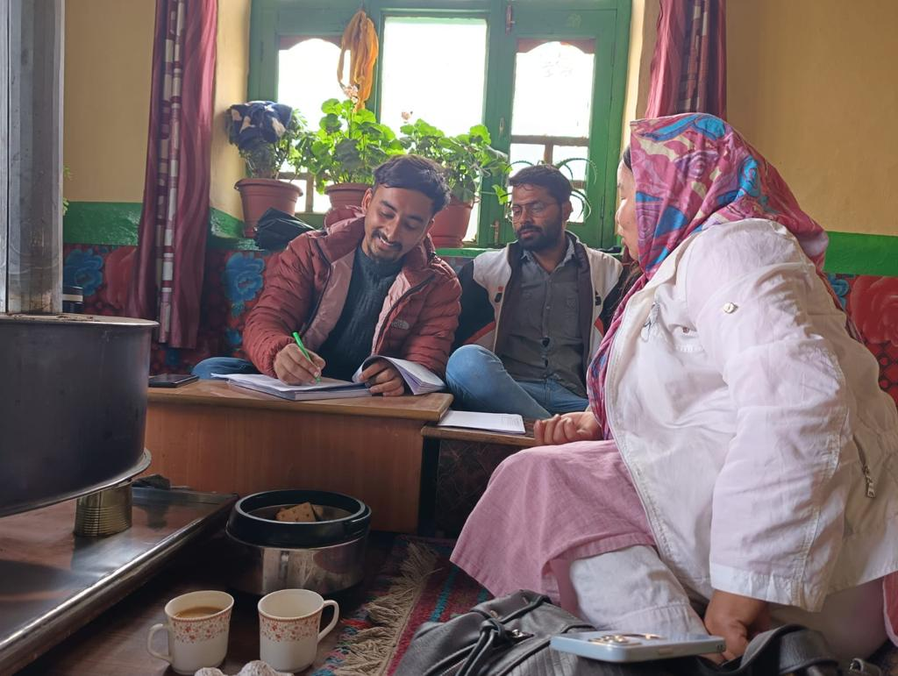

Annexure XIV

Micro Plan Assessment Criteria for Financing and Sanctioning
DMU: Kaza FTU: Tabo GP: Tabo Forest Beat: Poh BMC Sub Committee: Poh
 | Assessment Criteria | Achievement | Status at the time applying for approval
Process Related
1 | GP Level and ward level awareness done | 18/04/2021 | Done
2 | GP consent/ward consent to work with project obtained | 20/04/2021 | Done
3 | BMC SUB COMMITTEE formed/Executive committee constituted | 03/06/2022 | Done
4 | BMC SUB COMMITTEE registered | 03/06/2022 | Done
5 | MOU signed between DMU and BMC SUB COMMITTEE for undertaking micro planning and implementation | 24/07/2023 | Done
6 | EC 1st meeting held to explain their role and responsibilities | 03/06/2022 | Done
7 | BMC SUB COMMITTEE account opened |  | Done
8 | Percent of households represented in micro planning process (App) | 100% | Done
9 | Percent of women participants involved in micro planning process (App) | 95% | Done
10 | Collected information crosschecked and updated in general assembly | YES | Done
11 | Women, poor, youth and other communities were involved in micro planning process | YES | Done
12 | BMC SUB COMMITTEE involved in information analysis and finalizing key emerging activities | YES | Done
13 | Micro plan (FEMP, CD&LIP) approved by BMC SUB COMMITTEE in general assembly and confirmed by executive committee |  | Done
14 | Formats prescribed for MP (FEMP, CD&LIP) used by social and technical staff | YES | Done
15 | Total amount of FEMP, CD&LIP and convergence mentioned in MP | 34,76,064 | Done
16 | Days taken to complete MP (FEMP, CD&LIP) | 60
17 | Micro plan submitted by FTU to DMU
18 | Micro plan approved by the Head of DMU | 6/12/23 | Done
Output related
19 | List of Executive Committee members attached | Yes
20 | BMC SUB COMMITTEE contribution is there | In Progress
21 | Are FEMP and CD&LIP activities in line with project objectives | Yes
22 | Livelihood activities checked for initial technical feasibility and economic viability by micro planning team | Yes
23 | Convergence activities included | Yes
24 | BMC SUB COMMITTEE training and capacity building aspect included | Yes
25 | Costing of FEMP, CD&LIP checked by DMU | Yes
26 | Micro plan includes adversely affected households/group, if any | Yes
27 | PRA tools, wellbeing analysis, BMC SUB COMMITTEE resolution, maps of FEMP and other documents are annexed | Yes
28 | Sources of secondary information mentioned in the micro plan | Yes

Assessed by FMU Recommended by DMU Approved by PM

Annexure XV

Total Budget of BMC Sub Committee at Glance
S.N. | Activity |  | Unit Cost | 2023-24 |  |  | 2024-25 |  | 2025-26 |  | 2026-27 |  | 2027-28 |  | Total
 | Proposed Physical & Financial Coverage of Convergence Activities |  |  |  | phy | fin | phy | fin | phy | fin | phy | fin | phy | fin | phy | fin
1 | Total Plantation | 68,600/Ha |  |  |  |  | 9.36ha | 6,42,096 |  |  |  |  |  |  | 9.36ha | 6,42,096
2 | Total Maintenance | 10,000/ha (1st yr)  6,700/ha (2nd yr)  5100/ha (3rd yr) |  |  |  |  |  |  | 9.36ha | 93,600 | 9.36ha | 62,712 | 9.36ha | 47,736 | 9.36ha | 2,04,048
3 | Total SMC trenching | 15,750 |  |  |  |  | 9.36Ha | 1,47,420 |  |  |  |  |  |  | 9.36Ha | 1,47,420
4 | Total (S&WC) | 5,833Rmt |  |  |  |  | 60Rmt | 3,50,000 |  |  |  |  |  |  | 60Rmt | 3,50,000
5 | Total (community development) | 5,00,000 |  |  | 1 | 2,50,000 |  | 2,50,000 |  |  |  |  |  |  | 1 | 5,00,000
6 | Total SatoYama  Construction of irrigation canal/350 mtr. | 750/mt |  |  |  |  |  |  | 350mtr | 2,62,500 |  |  |  |  | 200mt | 2,62,500
7 | Total SatoYama  Maintenance of Old Water bodies/no | 25,000 |  |  |  |  |  |  | 3 | 75,000 |  |  |  |  | 3 | 75,000
8 | Total SatoYama  Public dustbins (Dry and wet)/no. | 15,000 |  |  |  |  |  |  | 5 | 75,000 |  |  |  |  | 5 | 75,000
9 | Total SatoYama  Corals for livestock’s | 15000 |  |  |  |  | 7 | 1,05,000 | 7 | 1,05,000 |  |  |  |  | 14 | 2,10,000
10 | Total SatoYama  Solar Hamam | 15000 |  |  | 5 | 75,000 |  |  |  |  |  |  |  |  | 5 | 75,000
11 | Total SatoYama  Feral Dogs Sterilization | 100000 |  |  |  |  |  |  | L/S | 2,00,000 |  |  |  |  | L/S | 2,00,000
12 | Total SatoYama  Incentive to dog catcher | 10000 |  |  |  |  |  |  | 10 | 1,00,000 |  |  |  |  | 10 | 1,00,000
13 | Total SatoYama  Orientation workshop on crop damage protection from wildlife | 10,000 |  |  |  |  | 1 | 10,000 |  |  |  |  |  |  | 1 | 10,000
14 | Total SatoYama  Gazebo tent for SHGs | 25,000 |  |  |  |  |  |  | 1 | 25,000 |  |  |  |  |  | 25,000
15 | Total (LIP) | 1,00,000 |  |  |  |  | 1 | 1,00,000 |  |  |  |  |  |  | 1 | 1,00,000
16 | Total (LIP) | 5,00,000 |  |  |  |  |  |  | 1 | 5,00,000 |  |  |  |  |  | 5,00,000
 | Total |  |  |  |  | 3,25,000 |  | 16,04,516 |  | 14,36,100 |  | 62,712 |  | 47,736 |  | 34,76,064

